Draft
Road Management Plan 2021

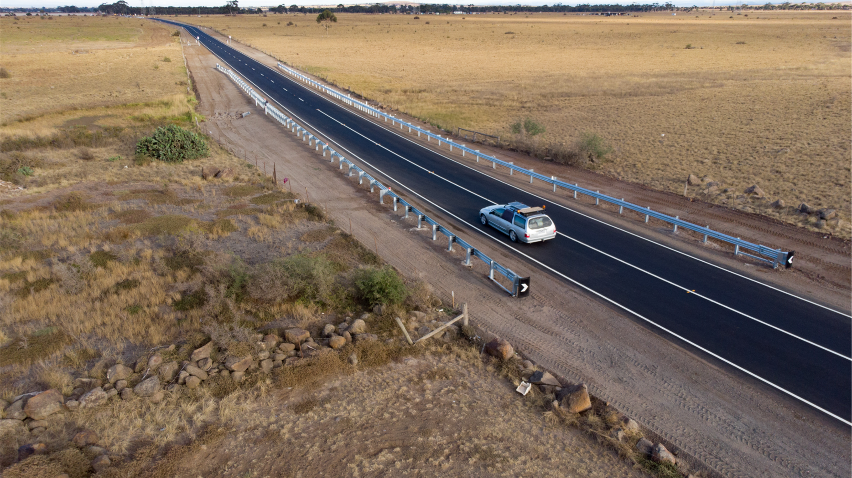

wyndhamcity

English
Wyndham City Council is responsible for local roads and footpaths, this Road Management Plan is one way that Council manages them. It aims to ensure that roads and footpaths are safe to use through road maintenance and its contents includes:
- When roads and footpaths are inspected for defects
- What is considered a defect
- How long it will take Council to respond to a defect once it is aware of it
If you would like assistance with this document, you can contact customer service on 1300 023 411 or Telephone Interpreting Service on 13 14 50 if an interpreter is required.

Hindi / हिंदी
Wyndham नगर परिषद स्थानीय सड़कों और फुटपाथों के लिए जिम्मेदार है, यह सड़क प्रबंधन योजना (Road Management Plan) परिषद के लिए उन्हें प्रबंधित करने का एक तरीका है। इसका उद्देश्य यह सुनिश्चित करना है कि सड़क रखरखाव के माध्यम से सड़क और फुटपाथ उपयोग के लिए सुरक्षित रहें और इसकी सामग्री में शामिल है:
- सड़कों और फुटपाथों का खराबी के लिए निरीक्षण कब किया जाता है
- खराबी किसे माना जाता है
- खराबी के बारे में पता चलने के बाद परिषद को इसके लिए प्रतिक्रिया करने में कितना समय लगेगा
यदि आपको इस दस्तावेज के साथ सहायता चाहिए, तो आप ग्राहक सेवा से 1300 023 411 पर संपर्क कर सकते/सकती हैं, या अगर आपको दुभाषिए की आवश्यकता है, तो आप टेलीफोन दुभाषिया सेवा (Telephone Interpreting Service) से 13 14 50 पर संपर्क कर सकते/सकती हैं।

Chinese (Simplified) / 普通话
Wyndham市议会负责管理本地道路和人行道。本《道路管理计划》是市议会管理道路和人行道的一种方式，旨在通过道路维护确保道路和人行道可以安全使用，计划内容包括：
- 何时检查道路和人行道是否有缺陷
- 哪些被认为是缺陷
- 市议会了解到缺陷后，需要多长时间才能做出反应
如果你想获得帮助理解本文件，可以拨打 1300 023 411 联系客户服务部，或者如果需要口译员，可以拨打13 14 50 联系电话口译服务处。
العربية
يتحمل مجلس مدينة ويندهام المسؤولية عن الطرق المحلية وممرات المشاة، وتعتبر خطة إدارة الطرق هذه من الوسائل التي يستخدمها المجلس في ذلك. تهدف الخطة إلى ضمان ملاءمة الطرق وممرات المشاة للاستخدام الآمن من خلال صيانتها، وتشمل محتوياتها:
- متى يتم فحص الطرق وممرات المشاة بحثًا عن أي خللٍ
- ما الذي يعتبر خللًا
- كم من الوقت ستتطلب استجابة المجلس للخلل بعد علمه بوجوده
إذا كنت ترغب في الحصول على مساعدة بشأن هذا المستند، يمكنك الاتصال بخدمة العملاء على
الرقم 411 023 1300 أو الاتصال هاتفيا خدمة الترجمة الفورية على الرقم 50 14 13 للحصول على مترجم فوري عند الضرورة.

Document Control

The Road Management Plan (RMP) is reviewed and revised as per the Road Management Act 2004. At a minimum it is reviewed every four years and revised as required. When a revision is proposed it is to be adopted by Council at an ordinary council meeting. The table below is a record of the revisions of the RMP.

Date | Summary of Changes | Record Number
18/02/2008 | Revised standards for inspection, maintenance & repair. | A322946
09/06/2009 | Amendments made to both the administrative procedures and the levels of service for inspection and maintenance activities. | A322942
24/06/2013 | Amendments made to both the administrative procedures and the levels of service for inspection and maintenance activities. | A1168001
14/06/2017 | Amendments made to both the administrative procedures and the levels of service for inspection and maintenance activities. | A1673153
2021 | A thorough update of the entire document, including formatting, wording, referencing and changes to standards.

The RMP is a public document, the current version can be viewed on the Wyndham City Council website as well as at the Civic Centre. For access to previous versions please contact customer service on 1300 023 411. This document is controlled by the Manager of Roads and Maintenance.
Table of Contents

Executive Summary 1
Glossary 2
SECTION 1 - INTRODUCTION 5
Purpose 6
Stakeholders 7
Road Authorities 8
Road Users’ Obligations 9
Incident Claims 10
Force Majeure 10
SECTION 2 - ROAD MANAGEMENT SYSTEM 11
Management System 12
Strategic Context 13
Identification of Defects 13
Levels of Service 14
Adjoining Municipalities 15
SECTION 3 – ASSET DESCRIPTIONS 16
Assets 17
Asset Classifications 18
Inclusions and Exclusions 19
Vehicle Crossovers (Driveway Crossovers) 20
Public Lighting 25
Traffic Signals 26
SECTION 4 - STANDARDS 27
Scheduled Inspections 28
Reactive Inspections 31
Intervention Levels 36
Exceptions 46
APPENDIX A – MAP OF WYNDHAM CITY 47

Executive Summary

Wyndham City Council manages local roads and paths. This Road Management Plan is one tool used to do this. It aims to ensure that the public can safely use roads and paths through road maintenance, as far as reasonable considering various factors such as the resources available. This plan applies to roads and paths within municipal road reserves. It does not apply to paths in parks for example.

While Wyndham City is responsible for local roads and paths, it is not responsible for everything to do with roads. The plan outlines responsibilities for various parties including the State Government, Councils, road users and neighbouring properties.

It then goes onto describe the assets within the road reserve, how they are classified, as well as the management system that Council uses when making decisions around roads.

Finally, the plan specifies in detail the standard of road maintenance adopted by Wyndham City Council including:
- When inspections occur
- What is considered a defect
- The response time to address a defect once it has been identified

This version of the Road Management Plan is a significant update to the previous version with the following major changes:
- The plan has been rewritten so that it is easier to understand
- An improvement to path maintenance to reduce tripping hazards

Glossary

Asset | An item of property. In this context usually infrastructure owned by Council such as roads, paths, and other road infrastructure.
Capital Work | Work where an asset is created, this can include the creation of new assets to replace existing ones and renewals.
Coordinating Road Authority | As defined in the Road Management Act 2004 and is usually the same as the land manager. e.g. Department of Transport is the Coordinating Road Authority for freeways and other declared roads.
Declared Roads | Land that has been formally declared a road by a road authority under an act of parliament.
Municipal Roads | As defined in the Road Management Act 2004 and refers to roads managed by Councils.
Non-road Infrastructure | As defined in the Road Management Act 2004 and refers to such things as gas pipes, sewerage pipes, electricity poles, bus shelters and roadside furniture.
Pathway | As defined in the Road Management Act 2004 and refers to footpaths, bicycle paths and shared use paths. This does not include bike lanes.
Periodic Maintenance | Tasks that are performed at a time interval to ensure that the asset continues to operate. Activities include inspections, repairs and replacements.
Public Road | As defined in the Road Management Act 2004.
Renewal | The replacement or refurbishment of an existing asset with a new asset or to an as-new condition.
Responsible Road Authority | As defined in the Road Management Act 2004, the road authority assigned operational responsibility for undertaking tasks.
Road Infrastructure | As defined in the Road Management Act 2004 and refers to structures and materials forming part of the road, pathway or shoulder such as asphalt, gravel and lane markers.
Road Management Function | As defined in the Road Management Act 2004.
Road Related Infrastructure | As defined in the Road Management Act 2004 and refers to infrastructure installed to facilitate the operation of the road such as traffic signals, street lights and drains.
Road Reserve | As defined in the Road Management Act 2004 and generally refers to the entire parcel of land that a road is located in.
Roadway | As defined in the Road Management Act 2004 and refers to the part of the road intended for driving motor vehicles on.
Routine Maintenance | Ongoing tasks that are undertaken to identify and prevent problems before they result in failure. Activities include inspections, minor repairs and replacements.
State Declared Roads | Roads that have been declared by a State government road authority and includes freeways, arterial roads and non-arterial State roads.

SECTION 1 - INTRODUCTION

Purpose

Wyndham City Council (WCC) is responsible for municipal roads, also known as local roads, within the Wyndham City area (Appendix 1). As per the Road Management Act 2004 (RMA), WCC has adopted the option of using a Road Management Plan (RMP) as part of its approach to managing municipal roads. This RMP aims to:
- Contribute to the provision of a safe and efficient road network
- Establish the system for the management of roadways, pathways and road related infrastructure that Council is responsible for based on policy, operational objectives and available resources
- Set the standards of the road management functions related to inspections, maintenance and repairs of roadways, pathways and road related infrastructure

The RMP applies to roads and paths within municipal road reserves. It does not apply to paths in parks for example.

The legislation that has been considered in developing this RMP includes:
- Road Management Act 2004
- Local Government Act 2020
- Local Government Act 1989
- Road Management (General) Regulations 2016
- Road Management Act 2004 – Code of Practice for Road Management Plans
- Road Management Act 2004 – Code of Practice Operational Responsibility for Public Roads
- Road Safety Act 1986

WCC policies and strategies have also been considered to ensure that this RMP is consistent with the adopted position of Council as a whole.

Stakeholders

In preparing this RMP, WCC has considered the interests of various stakeholders including:
- Motorists and other vehicle users
- Pedestrians
- Cyclists
- Ratepayers
- Emergency services
- Business and freight
- Wyndham City Council
- State Government road authorities and adjoining Councils

Road Authorities

There are multiple road authorities and understanding who is responsible for a section of public road can be difficult to determine as the lines of responsibilities are complex. The main road authorities are Councils and the State Government. The State Government Road Authority is made up of the following:
- Transport for Victoria
- Department of Transport (DoT)
- VicRoads
- Regional Roads Victoria

The State Government is responsible for State declared roads, which includes freeways and arterial roads. The roads that the State Government is responsible for can be found on:
- Register of Public Roads published by VicRoads as the formal register of public roads
- Maps of Declared Roads published by VicRoads as a supporting document

It is noted that Councils do have some responsibilities on arterial roads, such as for service roads and paths, for details please refer to Code of Practice Operational Responsibility for Public Roads.

The remaining public roads are generally municipal roads and are the responsibility of Council. Municipal roads within Wyndham City are listed on the WCC’s Register of Public Roads and is publicly available for viewing through the WCC website. If any assistance is required accessing it, please contact WCC customer service on 03 9742 0777.

Road Users’ Obligations
Road authorities are not required to provide roads and pathways that are in perfect condition or a perfectly safe to use, as this would cost a lot to achieve and is unrealistic. The RMA and the Road Safety Act 1986 require road users to take some responsibility when using a road. The responsibilities of road users under Section 17A of the Road Safety Act 1986 are highlight below as they are relevant to the functioning of the roads and the RMP.

17A Obligations of road users

- A person who drives a motor vehicle on a highway must drive in a safe manner having regard to all the relevant factors.
- A road user other than a person driving a motor vehicle must use a highway in a safe manner having regard to all the relevant factors.
(2A) For the purposes of subsections (1) and (2) and without limiting their generality, the relevant factors include the following—
  - the physical characteristics of the road
  - the prevailing weather conditions
  - the level of visibility
  - the condition of any vehicle the person is driving or riding on the highway
  - the prevailing traffic conditions
  - the relevant road laws and advisory signs
  - the physical and mental condition of the driver or road user
Note
The above factors are relevant to section 106 of the Road Management Act 2004 (Matters which may be considered to constitute contributory negligence).
(3) A road user must
  - take reasonable care to avoid any conduct that may endanger the safety or welfare of other road users
  - take reasonable care to avoid any conduct that may damage road infrastructure and non-road infrastructure on the road reserve
  - take reasonable care to avoid conduct that may harm the environment of the road reserve

Incident Claims

As per Section 115 of the RMA, a person who intends to take court proceedings in relation to a claim for damages arising out of the condition of a public road or infrastructure must first lodge a written notice with the Council within 30 days of the incident occurring. This written notice must contain enough information so that Council can undertake a site inspection and prepare a condition report.

Force Majeure

WCC will make all reasonable endeavours to meet the performance standards set in this RMP. There are circumstances beyond the control of WCC that may prevent these standards from being met such as:
- Natural disasters
- Emergencies
- Shortages of materials and labour
- Major breakdowns of equipment

In such circumstances WCC reserves the right to suspend its compliance with its RMP. This decision is to be made by the WCC Chief Executive Officer (CEO) after careful consideration. If the CEO decides to suspend the requirements of the RMP it will inform Council officers of this in writing that some, or all, of the timeframes and response times are to be suspended. Once the events beyond the control of Council have abated, or if the events have partly abated, the CEO will write to Council officers and inform them which parts of the RMP are to be reactivated and when.

SECTION 2 - ROAD MANAGEMENT SYSTEM

Management System

As per Section 7.5 of Road Management Act 2004 – Code of Practice for Road Management Plans, a RMP may include details of the management system that best meets a road authority’s needs to discharge its duty to inspect, maintain and repair public roads such as:
- Policies and procedures for setting standards
- Monitoring road condition
- Establishing priorities and allocating resources
- Delivering and auditing maintenance programs
- Recording asset performance
- Responding to incidents

Schedule 1 Road Management Act 2004 – Code of Practice for Road Management Plans
Diagram illustrating a management system for inspection, maintenance and repair of road
Infrastructure.
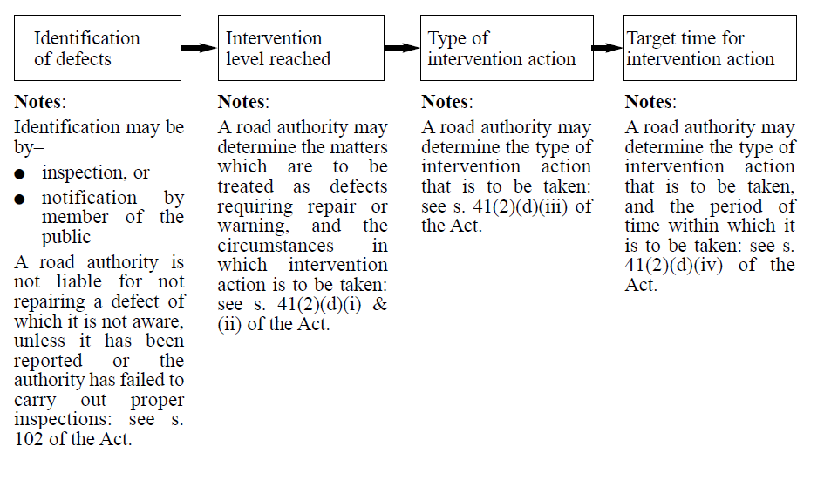

Strategic Context

The RMP is one element in a larger system that WCC uses to manage roads. This larger system includes strategies and plans such as:
- Council plan
- Financial plans and budgets
- Asset and service plans
- Transport strategies
- Road safety strategies

This RMP has been developed with consideration to these other plans and strategies so that it is in alignment with them.

Identification of Defects

Identification of defects may occur by:
- Inspections
- Request for service/ Notification by a member of the public

WCC conducts scheduled inspections on a regular basis as to proactively identify defects and minimise the risk to public safety. The timing for scheduled inspections are described in Section 4, Scheduled Inspections.

WCC also conducts reactive inspections in response to when member of the public notifies WCC of a possible defect, these notifications are recorded in the Customer Request Management Systems. The timing for reactive inspections are described in Section 4, Reactive Inspections.

Levels of Service

The levels of service for municipal roads managed by WCC are detailed in Section 4, Intervention Levels, and include the intervention level for each defect type and the response time to address them.

It is noted that during an inspection Council may use spray paint to mark pavements. This does not indicate that Council will repair a defect.

Adjoining Municipalities

WCC shares boundaries with the following local government municipalities:
- Hobsons Bay
- City of Greater Geelong
- Melton City
- Moorabool Shire
- Brimbank City

Some of these boundaries are in the centre of the road reserve, meaning that each Council is responsible for half of the road. As being responsible for half a road is not a practical way of managing an asset, WCC has entered into agreements with neighbouring Councils and has transferred some maintenance responsibilities. These agreements are recorded in memorandum of understandings. At the time of writing of this RMP the status of the memorandum of understandings with neighbouring Councils are as follows:

Neighbouring Council | Version | Record No.
Hobsons Bay | April 2021 | A3019826
City of Greater Geelong | December 2020 | A2875986
Melton City | Under revision
Moorabool Shire | None
Brimbank City | None

SECTION 3 – ASSET DESCRIPTIONS

Assets

WCC’s responsibility for municipal roads listed on the Register of Public Roads includes being responsible for:
- Road pavements
- Pathways (footpaths and shared user paths)
- Bridges
- Drainage
- Traffic signs

The table below shows the roads, paths and road related infrastructure assets WCC is responsible for within the road reserve and their approximate quantities as of the date of publication of this RMP.

Item | Quantity
Road pavements | 1635 km
Pathways (within road reserve) | 1890 km
Kerb and channel | 2632 km
Bridges and major culverts | 130
Traffic signals | 71

WCC keeps detailed records of assets in its asset management system.

Asset Classifications

WCC classifies roads and paths into categories based on their importance to the transport network, as well as the risk to the public if a defect does occur. These categories are used to determine the standard of maintenance (inspection frequencies, intervention levels and response times). Roads and paths of a higher priority may receive a higher standard of maintenance. This is not always the case though.

Road Classification | Description
Main | Distribute traffic between the VicRoads network and provide access to the local network
Collector | Distribute traffic between the Main network and the local system
Local access | Provide abutting properties with access to the road network

Path Classification | General Description
3 | Main shopping centres
2 | Small shopping centres, schools, aged care facilities.
1 | Residential and industrial streets

Inclusions and Exclusions

The road reserve is a shared space that contains both road related infrastructure and other assets such as telecommunications, gas pipes and sewerage. The standards set in the RMP relate to roadways, pathways and road related infrastructure only. See table below for examples of what the RMP covers and does not cover.

RMP covers | RMP does not cover
Road materials  (E.g. asphalt, concrete, gravel) | Gas pipes
Road shoulders | Water pipes
Path materials  (E.g. asphalt, concrete) | Telecommunications
Traffic signals | Electricity poles and cables
Kerb and channel | Rail infrastructure
Street lighting | Bus stops
Bridges and culverts | Fences
Street signs | Roadside and nature strips
Road drains | Tree condition
 | Speed limits
 | Design standards
 | Rail crossings
 | Stormwater drains that service private land

Vehicle Crossovers (Driveway Crossovers)

Section 206 and Schedule 10 of the Local Government Act 1989 gives Council powers over roads. As allowed in Clause 12, Schedule 10 Council has decided that it will require, the property owner for which the vehicle crossover provides access to and from the road, to construct, inspect, maintain, repair and renew vehicle crossovers. This responsibility extends to:
- The area between the property boundary and the road
- The section of footpath within the vehicle crossover
- The layback, including any kerb and channel (gutter)
- Drainage, including endwalls, headwalls and wingwalls
Urban vehicle crossover example

Property Boundary
Footpath
Footpath

Vehicle Crossover

Kerb and Channel
Kerb and Channel
Layback
Road

LEGEND
Property owner responsibility
Rural vehicle crossover example
Property Boundary
• Endwall
• Headwall
• Wingwall
Vehicle Crossover

Open table drain
Open table drain
Underground drain

Road

LEGEND
Property owner responsibility

There are some situations where more than one property is served by what (in other circumstances) would be seen as a single vehicle crossover. In these situations, for the purposes of provision, maintenance, repair and reconstruction, the shared use section of the vehicle crossover is deemed to be road and therefore the responsibility of Council.

Vehicle Crossover

Vehicle Crossover

Road

LEGEND
Property owner responsibility
Council responsibility

Where two single vehicle crossovers abut, the vehicle crossovers remain the responsibility of the relevant property owner.
Property Boundary
Footpath

Footpath

Vehicle Crossover
2
Vehicle Crossover
1

Layback
Kerb and Channel
Kerb and Channel
Road

LEGEND
Property owner responsibility

Where there is a parking bay (for which construction has been previously approved by Council) next to a vehicle crossover, Council will be responsible for the section of the vehicle crossover next to the parking bay, up to the boundary of the parking bay furthest from the road pavement.

Property Boundary
Footpath

Vehicle Crossover

Footpath

Parking bay
Layback
Kerb and Channel
Kerb and Channel
Road
Property owner responsibility
LEGEND
Council responsibility

Public Lighting

Councils are responsible for public lighting within the road reserve. WCC engages Powercor, the electricity distribution company in Wyndham City, to operate and maintain public lighting on its behalf. Inspection schedules, intervention levels and response times are determined by Powercor. Any identification of defects for public lighting will be forwarded to Powercor for action.

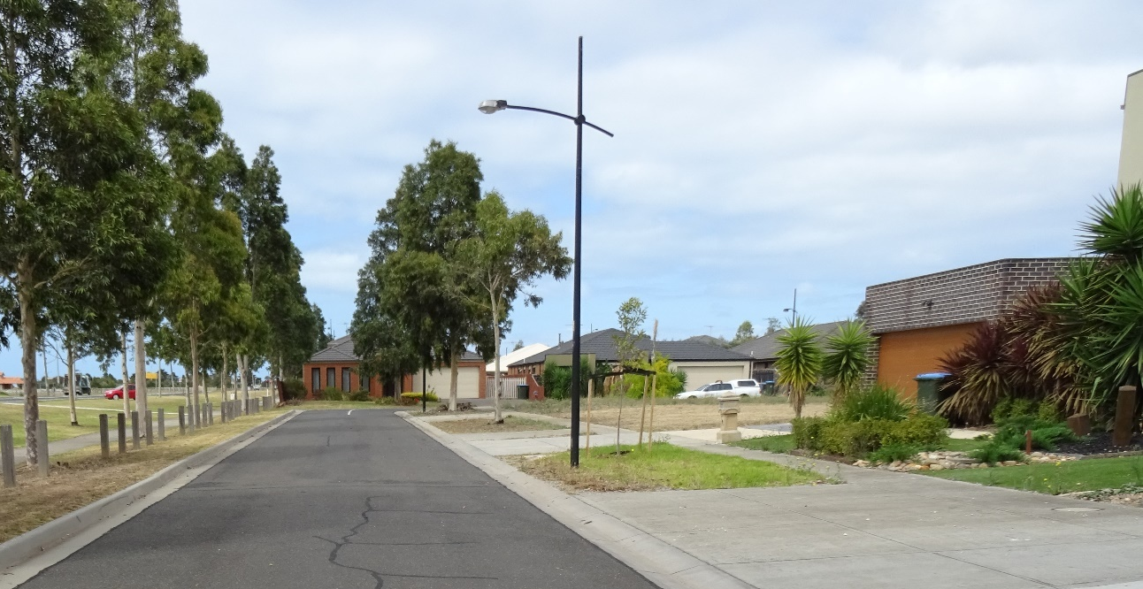

Traffic Signals

Responsibility for traffic signals is as per Section 9 of the Road Management Act 2004 – Code of Practice Operational Responsibility for Public Roads. WCC is responsible for traffic signals on the local road network. The State Government is responsible for traffic signals on State declared road, including intersections between a State declared and a local road.

WCC has opted to contract the Department of Transport (DoT) to operate and maintain traffic signals on its behalf. Inspection schedules, intervention levels and response times are determined by DoT. Any identification of defects for traffic signals will be forwarded to DoT for action.

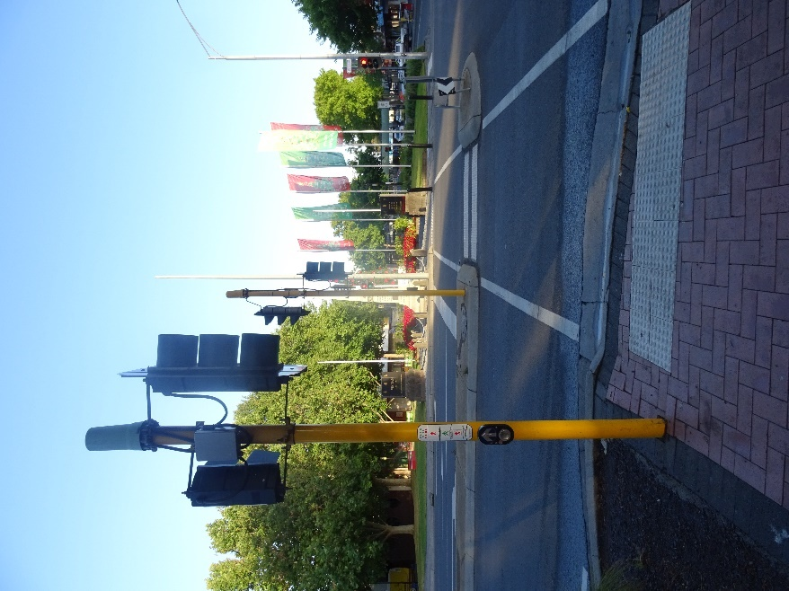

SECTION 4 - STANDARDS

Scheduled Inspections

Roadways
INSPECTION | ASSET SEGMENT | FREQUENCY/RESPONSE TIME
INSPECTION | ASSET SEGMENT | Main | Collector | Local Access
Compliance inspections are undertaken as part of an inspection regime or in conjunction with routine patrol maintenance to determine compliance with the approved intervention levels and to determine risk. | All road segments (except bus shelters). | Inspect at least every 6 weeks. | Inspect at least every 6 months. | Inspect at least every 12 months.
 | Bus shelters (Council managed bus shelters only, not Public Transport Victoria bus stops) | Inspect at least every 12 months. | Inspect at least every 12 months. | Inspect at least every 12 months.
Condition inspections are undertaken by suitably qualified and experienced personnel to determine overall structural condition of assets. The inspections may include risk assessment. | All road segments. | 3 year Pavement Management Survey. | 3 year Pavement Management Survey. | 3 year Pavement Management Survey.
 | Bridges/Major Culverts – inspections as per the VicRoads bridge Inspection Manual. | 3 year inspection cycle | 3 year inspection cycle | 3 year inspection cycle

Kerb and Channel
INSPECTION | ASSET SEGMENT | FREQUENCY/RESPONSE TIME
INSPECTION | ASSET SEGMENT | Main | Collector | Local Access
Compliance inspections are undertaken as part of an inspection regime or in conjunction with routine patrol maintenance to determine compliance with the approved intervention levels and to determine risk. | Response inspections are ad hoc inspections of assets consequent to notifications from parties, to verify compliance with maintenance standards and to determine risk. | Inspect within 20 working days of notification. | Inspect within 20 working days of notification. | Inspect within 20 working days of notification.

Street Trees
INSPECTION | ASSET SEGMENT | FREQUENCY/RESPONSE TIME
INSPECTION | ASSET SEGMENT | Main | Collector | Local Access
Compliance inspections are undertaken as part of an inspection regime or in conjunction with reactive maintenance and block clearance activities to determine compliance with the approved intervention levels and to determine risk. | General compliance – undertaken as part of the road inspection regime, the block pruning regime or in conjunction with reactive maintenance to determine compliance with the approved intervention levels. | Inspect trees at least every 3 years. | Inspect trees at least every 3 years. | Inspect trees at least every 3 years.
Pathways
INSPECTION | ASSET SEGMENT | FREQUENCY/RESPONSE TIME
INSPECTION | ASSET SEGMENT | 3. High | 2. Medium | 1. Low
Compliance inspections are undertaken as part of an inspection regime to determine compliance with the approved intervention levels and to determine risk. | All paths. | Inspect at least every 3 months. | Inspect at least every 6 months. | Inspect at least every 14 months.
Condition inspections are undertaken by suitably qualified and experienced personnel to determine overall structural condition of assets. The inspections may include risk assessment. | All paths. | 3 year Condition Survey. | 3 year Condition Survey. | 3 year Condition Survey.

Reactive Inspections

Roadways
INSPECTION | ASSET SEGMENT | FREQUENCY/RESPONSE TIME
INSPECTION | ASSET SEGMENT | Main | Collector | Local Access
Reactive inspections are ad hoc inspections of assets consequent to notifications from parties, to verify compliance with maintenance standards and to determine risk.  Reactive inspections are ad hoc inspections of assets consequent to notifications from parties, to verify compliance with maintenance standards and to determine risk. | Driving surface defects. | Inspect within 5working days of notification. | Inspect within 10 working days of notification. | Inspect within 20 working days of notification.
 | Damaged or missing regulatory and warning signs. | Inspect within 5 working days of notification. | Inspect within 5 working days of notification. | Inspect within 5 working days of notification.
 | Damaged all other road related signage including missing guideposts, marker posts, delineators, pavement markings, line marking and damaged or missing street furniture. | Inspect within 10 working days of notification. | Inspect within 10 working days of notification. | Inspect within 10 working days of notification.
 | Bridges/Major Culverts. | Inspect within 5 working days of notification. | Inspect within 5 working days of notification. | Inspect within 5 working days of notification.
 | Where a flood is likely to warrant the closure of a bridge/major culvert | Inspect within 4 hours of notification | Inspect within 4 hours of notification | Inspect within 4 hours of notification
 | Missing/collapsed drainage pit lids. | Inspect within 3 working days of notification. | Inspect within 3 working days of notification. | Inspect within 3 working days of notification.
 | Damaged or missing guard fencing. | Inspect within 3 working days of notification. | Inspect within 3 working days of notification. | Inspect within 3 working days of notification.
 | Emergency surface cleaning/clearing. | Inspect within 4 hours of notification. | Inspect within 6 hours of notification. | Inspect within 1 working day
 | Damaged bus shelters (Council managed bus shelters only, not Public Transport Victoria bus stops). | Inspect within 5 days of notification. | Inspect within 5 days of notification. | Inspect within 5 days of notification.

Kerb and Channel
INSPECTION | ASSET SEGMENT | FREQUENCY/RESPONSE TIME
INSPECTION | ASSET SEGMENT | Main | Collector | Local Access
Reactive inspections are ad hoc inspections of assets consequent to notifications from parties, to verify compliance with maintenance standards and to determine risk. | Kerb & Channel segment defects. | Inspect within 20 working days of notification. | Inspect within 20 working days of notification. | Inspect within 20 working days of notification.

Pathways
INSPECTION | ASSET SEGMENT | FREQUENCY/RESPONSE TIME
INSPECTION | ASSET SEGMENT | 3. High | 2. Medium | 1. Low
Reactive inspections are ad hoc inspections of assets consequent to notifications from parties, to verify compliance with maintenance standards and to determine risk. | Pathway defects | Inspect within 15 working days of notification. | Inspect within 15 working days of notification. | Inspect within 20 working days of notification.

Street Trees
INSPECTION | ASSET SEGMENT | FREQUENCY/RESPONSE TIME
INSPECTION | ASSET SEGMENT | Main | Collector | Local Access
Reactive inspections are ad hoc inspections of assets consequent to notifications from parties, to verify compliance with maintenance standards and to determine risk. | Where tree or part of the tree has fallen across a path or road. | Inspect within 1 working day of notification. | Inspect within 1 working day of notification. | Inspect within 1 working day of notification.
 | Where tree or part of the tree has fallen across a power line. | Inspect within 4 hours of notification. | Inspect within 4 hours of notification. | Inspect within 4 hours of notification.
 | All other tree defects including intrusion into pedestrian and/or vehicle clearance zone and sight distance issues. | Inspect within 10 working days of notification. | Inspect within 10 working days of notification. | Inspect within 10 working days of notification.

Vegetation (General)
INSPECTION | ASSET SEGMENT | FREQUENCY/RESPONSE TIME
INSPECTION | ASSET SEGMENT | Main | Collector | Local Access
Reactive inspections are ad hoc inspections of assets consequent to notifications from parties, to verify compliance with maintenance standards and to determine risk. | Both within path environments and road environments, the management of vegetation so as to provide:  - Line of sight at intersections  - Line of sight to regulatory signage  Suitable access to the vehicle envelope for the planned usage of the road/path | Inspect within 10 working days of notification | Inspect within 10 working days of notification | Inspect within 10 working days of notification

Intervention Levels

Kerb and Channel
MAINTENANCE ACTION | INTERVENTION LEVELS | FREQUENCY/RESPONSE TIME
MAINTENANCE ACTION | INTERVENTION LEVELS | Main | Collector | Local Access
Take remedial and/or protection action and/or undertake temporary repairs. | K&C defect being:  - level (height) differential greater than 50mm  - crack width greater than 50mm | Take remedial action where required within 20 working days of inspection. If permanent works required place on budgeted works program. | Take remedial action where required within 20 working days of inspection. If permanent works required place on budgeted works program. | Take remedial action where required within 20 working days of inspection. If permanent works required place on budgeted works program.

Roadways
MAINTENANCE ACTION | INTERVENTION LEVELS | FREQUENCY/RESPONSE TIME
MAINTENANCE ACTION | INTERVENTION LEVELS | Main | Collector | Local Access
Take remedial and/or protection action and/or undertake temporary repairs. | Asphalt surface defect being:  - a pothole exceeding 200mm diameter or 75mm in depth  - an edge break exceeding 100mm width or 75mm depth  - individual unconnected pavement defects where the depth, measured with a 1.5 m straight edge, is greater than 100 mm and affects an area greater than 2 m² | Take remedial action where required within 5 working days of inspection. Carry out repairs to an appropriate level within 30 working days of inspection. | Take remedial action where required within 10 working days of inspection. Carry out repairs to an appropriate level within 30 working days of inspection. | Take remedial action where required within 20 working days of inspection. Carry out repairs to an appropriate level within 30 working days of inspection.
 | Unsealed shoulder and/or roadway:  - corrugation (repetitive 75mm depth)  - potholes (300mm diameter or 100mm depth)  - rutting (100mm depth wheel-path impression)  - loss of crown or cross fall | Take remedial action where required within 5 working days of inspection. Carry out repairs to an appropriate level within 30 working days of inspection. | Take remedial action where required within 10 working days of inspection. Carry out repairs to an appropriate level within 30 working days of inspection. | Take remedial action where required within 20 working days of inspection. Carry out repairs to an appropriate level within 45 working days of inspection.
Take remedial and/or protection action and/or undertake temporary repairs. | Replace/repair missing or damaged regulatory and warning signs. | Take remedial action where required within 5 working days of inspection. Carry out repairs to an appropriate level within 15 working days of inspection. | Take remedial action where required within 5 working days of inspection. Carry out repairs to an appropriate level within 30 working days of inspection. | Take remedial action where required within 5 working days of inspection. Carry out repairs to an appropriate level within 30 working days of inspection.
 | Damaged all other road related signage including missing guideposts, marker posts, delineators, pavement markings, line marking and damaged or missing street furniture. | Take remedial action where required within 10 working days of inspection. Carry out repairs to an appropriate level within 45 working days of inspection. | Take remedial action where required within 10 working days of inspection. Carry out repairs to an appropriate level within 45 working days of inspection. | Take remedial action where required within 10 working days of inspection. Carry out repairs to an appropriate level within 45 working days of inspection.

MAINTENANCE ACTION | INTERVENTION LEVELS | FREQUENCY/RESPONSE TIME
MAINTENANCE ACTION | INTERVENTION LEVELS | Main | Collector | Local Access
Take remedial and/or protection action and/or undertake temporary repairs. | Missing / collapsed drainage pit lids. | Take remedial action where required within 3 working days of inspection. Carry out repairs to an appropriate level within 20 working days of inspection. | Take remedial action where required within 3 working days of inspection. Carry out repairs to an appropriate level within 20 working days of inspection. | Take remedial action where required within 3 working days of inspection. Carry out repairs to an appropriate level within 20 working days of inspection.
 | Damaged or missing guard fencing. | Take remedial action where required within 3 working days of inspection. If permanent works required place on budgeted works program. | Take remedial action where required within 3 working days of inspection. If permanent works required place on budgeted works program.. | Take remedial action where required within 3 working days of inspection. If permanent works required place on budgeted works program.
Take remedial and/or protection action and/or undertake temporary repairs. | Regular maintenance of bridge decking, wearing surface, drainage, abutments and side rails including temporary repairs or erecting appropriate barriers, removal of dirt and gravel from kerbs and expansion joints, keeping the waterway area clear and free of weeds and debris. | Take remedial action where required within 5 working days of inspection. If permanent works required place on budgeted works program. | Take remedial action where required within 5 working days of inspection. If permanent works required place on budgeted works program. | Take remedial action where required within 5 working days of inspection. If permanent works required place on budgeted works program.
 | Where a flood warrants the closure of a bridge/major culvert. | Take remedial action where required within 2 hours of inspection. | Take remedial action where required within 2 hours of inspection. | Take remedial action where required within 2 hours of inspection.

MAINTENANCE ACTION | INTERVENTION LEVELS | FREQUENCY/RESPONSE TIME
MAINTENANCE ACTION | INTERVENTION LEVELS | Main | Collector | Local Access
Take remedial and/or protection action and/or undertake temporary repairs. | Damaged bus shelters. | Take remedial action where required within 5 days of inspection. Carry out repairs to an appropriate level within 3 months of inspection. | Take remedial action where required within 5 days of inspection. Carry out repairs to an appropriate level within 3 months of inspection. | Take remedial action where required within 5 days of inspection. Carry out repairs to an appropriate level within 3 months of inspection.
 | For concrete roads.  Defect is:  - level (height) differential greater than 20mm  - crack width greater than 50mm | Take remedial action where required and/or undertake temporary repairs within 15 working days of inspection. If permanent works required place on budgeted works program. | Take remedial action where required and/or undertake temporary repairs within 15 working days of inspection. If permanent works required place on budgeted works program. | Take remedial action where required and/or undertake temporary repairs within 20 working days of inspection. If permanent works required place on budgeted works program.
Street Trees
MAINTENANCE ACTION | INTERVENTION LEVELS | FREQUENCY/RESPONSE TIME
MAINTENANCE ACTION | INTERVENTION LEVELS | Main | Collector | Local Access
Take remedial and/or protection action and/or undertake temporary repairs. | Where a tree and/or part of a tree has fallen across a path, road or power line. | Take remedial action where required within 2 hours of inspection. Carry out permanent repairs within 10 working days of inspection. | Take remedial action where required within 2 hours of inspection. Carry out permanent repairs within 10 working days of inspection. | Take remedial action where required within 2 hours of inspection. Carry out permanent repairs within 10 working days of inspection.
 | Other tree defects:  - intrusion into pedestrian and/or vehicle clearance zone  - diseased or poisoned tree  - dead or dying tree | Take remedial action where required within 10 working days of inspection. Carry out permanent repairs within 40 working days of inspection. | Take remedial action where required within 10 working days of inspection. Carry out permanent repairs within 40 working days of inspection. | Take remedial action where required within 10 working days of inspection. Carry out permanent repairs within 40 working days of inspection.
Take remedial and/or protection action and/or undertake temporary repairs. | Where a tree is intruding into the power line clearance zone. | Maintenance is carried out in accordance with Council’s Facilities & Open Space Electrical Line Clearance Management Plan which is updated annually. | Maintenance is carried out in accordance with Council’s Parks and Open Space Management Strategy. | Maintenance is carried out in accordance with Council’s Parks and Open Space Management Strategy.
 | Where a tree impacts significantly on planned light spill from streetlights | Carry out permanent repairs within 40 working days of inspection. | Carry out permanent repairs within 40 working days of inspection. | Carry out permanent repairs within 40 working days of inspection.

Vegetation (General)
MAINTENANCE ACTION | INTERVENTION LEVELS | FREQUENCY/RESPONSE TIME
MAINTENANCE ACTION | INTERVENTION LEVELS | Main | Collector | Local Access
Take remedial and/or protection action and/or undertake temporary repairs. | Both within path environments and road environments the management of vegetation as to provide:  - line of sight at intersections  - line of sight to regulatory signage  - suitable access to the vehicle envelope for the planned usage of the road/path | Undertake permanent repairs within 40 working days of inspection. | Undertake permanent repairs within 40 working days of inspection. | Undertake permanent repairs within 40 working days of inspection.

Pathways
MAINTENANCE ACTION | INTERVENTION LEVELS | FREQUENCY/RESPONSE TIME
MAINTENANCE ACTION | INTERVENTION LEVELS | 3. High | 2. Medium | 1. Low
Take remedial and/or protection action where required and/or place on budgeted works program for future works. | Defect is:  - crack width greater than 50mm  (does not include chipping or pot holes)  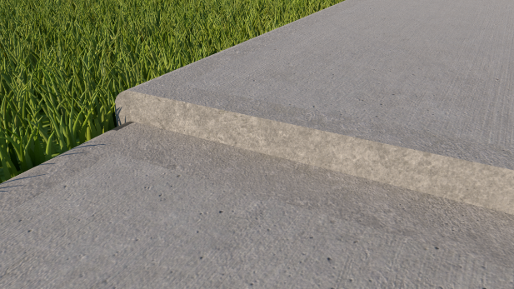  - level (height) differential greater than 20mm  Level differential | Take remedial action where required and/or undertake temporary repairs within 15 working days of inspection. If permanent works required place on budgeted works program. | Take remedial action where required and/or undertake temporary repairs within 15 working days of inspection. If permanent works required place on budgeted works program. | Take remedial action where required and/or undertake temporary repairs within 20 working days of inspection. If permanent works required place on budgeted works program.

Exceptions

It is WCC’s intention that the standards in this RMP are the adopted standards. At the discretion of WCC, it may choose to repair or replace assets and achieve a higher standard than what has been set in this RMP for the following reasons:
- Where it would be better value for money
- Where it would be more practical

When these occur, it is by exception and are not intended to change the adopted standards in this RMP.

APPENDIX A – MAP OF WYNDHAM CITY

