Road Management Plan Review 2021



wyndhamcity

Prepared by Daniel Kade
Senior Operations Engineer
Roads and Maintenance
August 2021
Table of Contents

Introduction 1

Review Process 2

Comments Received 4

Road Authority Comparison 15

Community Engagement 16

Conclusion 16

Contact Details 17

Introduction

Wyndham City Council (WCC) is the coordinating road authority for local roads within the municipality of Wyndham City. As per the Road Management Act 2004 (RMA), WCC has adopted the option of using a road management plan (RMP) as part of its approach to managing road infrastructure, the current RMP being dated 2017. The RMP aims to:
- Contribute to the provision of a safe and efficient road network for public use
- Establish management system for roads that Council is responsible for based on policy, operational objectives and available resources
- Set the standards of the road management functions around inspections, maintenance and repairs

The RMP applies to municipal roads within Wyndham City as per the register of public roads.

The RMA requires that the RMP be reviewed at set time intervals, as described in the Road Management (General) Regulations 2016. This review is to be completed by 31 October 2021. The Road Management (General) Regulations 2016 state that in conducting a review of its RMP a road authority must ensure that the standards in relation to, and the priorities to be given to, the inspection, maintenance and repair of the roads and classes of road to which the plan applies are appropriate. This report has been created to provide an overview of the review, its findings and conclusions.

Review Process

The review was coordinated by the WCC Roads and Maintenance department and led by Mauro Covacci and Daniel Kade. Internal stakeholders consulted during the review include:
- Roads and Maintenance
- Vibrant City Centres
- Legal Counsel
- Risk and Compliance
- Director City Operations
- City Transport
- Asset Management
- Engineering Development
- Climate Futures
- Open Spaces
- Conservation and Arboriculture



The scope of this review includes:
- Assessing the reasonableness of the RMP
- Assessing the resourcing and delivery of the RMP
- Assessing the accessibility of the RMP
- Legal review of the RMP
- Literature review of RMPs of other road authorities
- Literature review of legislation, regulations and codes of practice
- Evaluating the alignment of the RMP with other Council strategies and plans

Scope of this review does not include:
- The approval of any budget changes
- Third party review of the RMP



Comments Received

Comments received from internal stakeholders during the review are contained in this section as well as the responses. Responses came from the appropriate person or group at Council depending on the comment.

Comment 1
There are assets that are not included in the RMP such as drainage, TGSI (tactiles), line marking and slip resistance testing of footpaths. Should these be included in the RMP?

Response
The RMP is to include assets that have inspection schedules, intervention levels and response times that are defined precisely and that can be delivered consistently. If this cannot be achieved, then they should not be included in the RMP. Assets that are not included in the RMP can be managed by another process, E.g. Australian Standards. This is for legal reasons, as the RMP is used by road authorities as a defence against negligence claims it is heavily scrutinised in a legal challenge. As a result, the RMP should be extremely precise, clear and understandable to reduce the risk of legal liability.

Comment 2
What options are available for risk-based intervention levels as opposed to specified intervention levels?

Response
Considering legal precedence and legal advice it seems that it is best practice for the RMP to have precisely specified intervention levels as opposed to risk based processes where intervention levels could vary. It is strongly advised to utilise specified intervention levels in the RMP.
Comment 3
Should tree pruning for power lines be included in the RMP?

Response
Facilities and Open Space have been requested to review and update the sections related to tree pruning around power lines. These sections have been updated to reference the Electrical Line Clearance Management Plan. See comment 13 for further discussion around the inclusion of trees in the RMP.

Comment 4
Redundant and out of date references are to be updated or removed from the RMP.

Response
There are references that are out of date that have been identified such as:
- VicRoads as a road authority, which should now be Transport Victoria
- References to old policies, plans and procedures
- Reference to the STEP program which WCC does not participate in any longer

The RMP will be reviewed entirely to update any redundant and out of date references.

Comment 5
There are some roads and paths that are unique, such as concrete lane ways and shared paths. Should specific intervention levels be developed for these?

Response
It is acknowledged that the intervention level for roads, which are best suited for asphalt roads whose primary function is to carry vehicular traffic, may be insufficient for concrete roads as well as laneways that experience significant pedestrian use. New intervention levels are to be developed for concrete roads and lane ways; the standard is to be the same as concrete footpaths.

Comment 6
Discretionary items can create legal risks if they are interpreted as being part of the standard level of service and not discretionary.

Response
WCC believes that discretionary works, above and beyond the intervention levels, can achieve value for money for the community, when used during renewal works. Discretionary works are to be articulated clearly in the RMP so that they can be delivered without the risk of it being the adopted standard or intervention level.

Comment 7
Consider changing the footpath intervention level from 30mm to 20mm for height differentials to reduce tripping hazards.
More than 20mm
More than 30mm
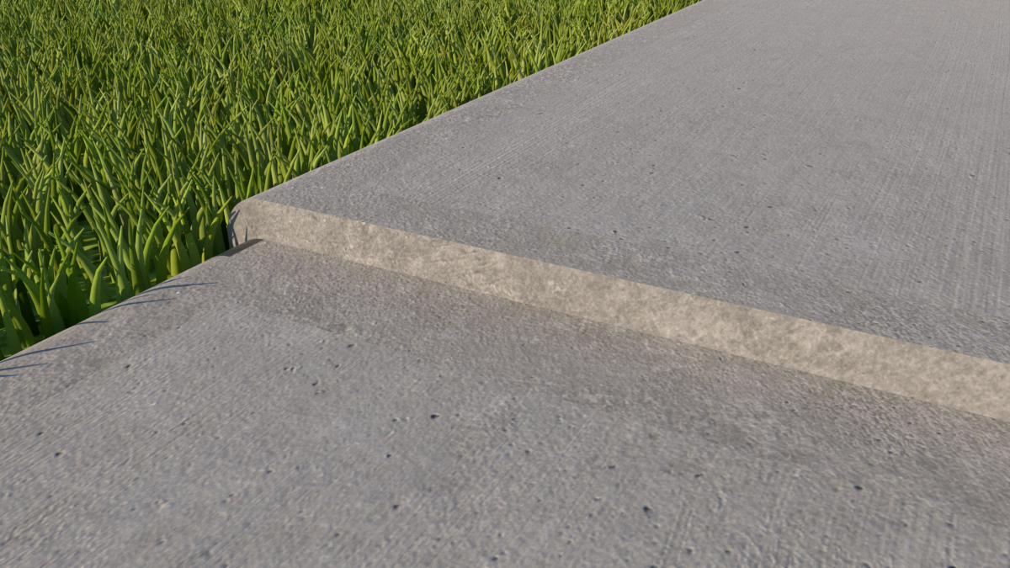
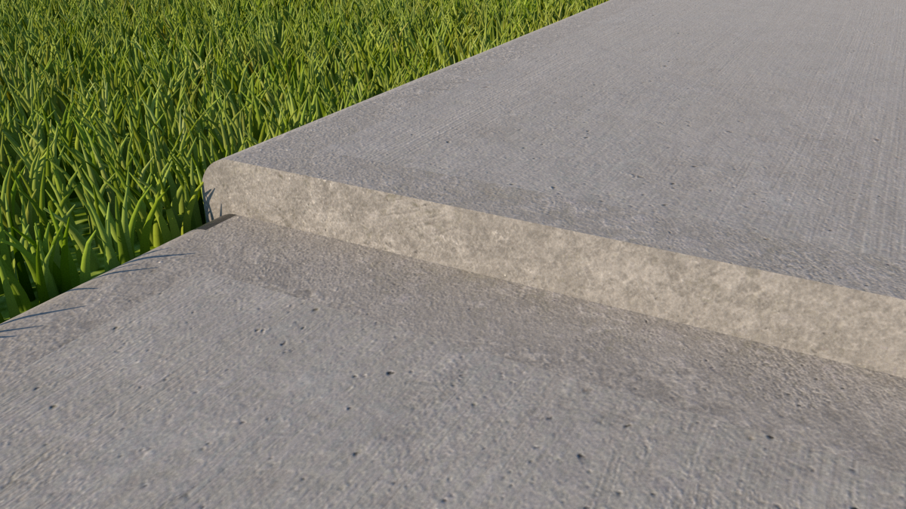

Proposed intervention level
Current intervention level

Response
Operations Engineering will work with Asset Rehabilitation and management to determine if this proposal is achievable and appropriate to include in the RMP. The cost estimate to the budget for such a change is an additional $1 million per annum. This will be recommended to Council for its consideration and approval. Removing all footpath height differentials was also considered, the estimated cost of doing this is $4.7 million each year. This was considered a too higher cost and will not be recommended for consideration.

Comment 8
Consider including night-time inspections in the RMP, to identify street signs that are not reflective.

Response
Operations Engineering has meet with Civil Maintenance to determine if this proposal is achievable and appropriate to include in the RMP. After a discussion it was judged that the main cause of street signs and road reflectors not being reflective is dirt, as opposed to product defects. Cleaning of dirt can be undertaken during the day. It is believed that street signs not being reflective from product defects are rare and that undertaking scheduled night-time inspections to identify these is a too higher cost relative to the expected benefits. An alternative approach to identifying non-reflective street signs is for shift workers, such as street sweepers, to use ad hock reporting to identify them.

Comment 9
A couple of staff members have raised concerns that the current inspection schedule will not be met moving forward as a result of the new IT systems being implemented, which requires a lot more data entry and time to complete an inspection.

Response
These concerns are to be passed on to management as they are regarding resourcing and corporate systems.

Comment 10
Various stakeholders raised concerns that the RMP can be difficult or confusing to understand.

Response
The RMP will be reviewed to ensure that it can be understood by a wide range of readers including:
- Council staff
- General public
- Lawyers

It is expected that much of the RMP will be re-written so that:
- It uses plain English
- It is clearer to understand
- It is more accessible
- The formatting is improved
- It uses diagrams and photos to help communicate complex and technical items

Comment 11
Responsibilities around vehicle crossovers may be unclear.

Response
Diagrams will be added to a revised RMP to clearly indicate responsibilities around crossovers. In addition to this legal advice will be obtained around responsibilities for crossovers. It is noted that section 206 and Schedule 10 of the Local Government Act 1989 gives Council powers over crossings over footpaths. Clause 12, Schedule 10 allows Council to require any person to construct, inspect, maintain, repair and renew crossings over footpaths (driveways, vehicle crossovers). It is this power that WCC will reply upon to require, the property owner for which the driveway provides access to and from the road, to construct, inspect, maintain, repair and renew vehicle crossovers.

Comment 12
Can intervention levels for footpaths be based on risk? I.e. Higher standards in shopping centres and near aged care facilities?

Response
Due to concerns about legal liability intervention levels for footpaths should be consistent throughout the entire municipality. Footpaths are already grouped into categories based on risk. Extending the risk-based approach further and creating additional categories is not recommended.

Comment 13
Should trees and the associated standards be removed from the RMP as they are not road-related infrastructure?

Response
The RMA does not specify in detail what can or not be included in the RMP. The Code of Practice for Road Management Plans states that a RMP may contain standards related to roads, pathways and road-related infrastructure. As trees are neither of these should they be included in the RMP or removed? Further to this if trees are included would they be given the legal protections offered by complying with the RMP as they are not road-related infrastructure? If there was a negligence claim that went to court, could Council rely on a defence based on compliance with the RMP or might this defence be found to be invalid? This query is to be submitted to legal counsel to provide advice on.

Comment 14
Is the RMP in alignment with other Council strategies and plans?

Response
The RMP has been considered against other Council strategies and plans including:
- Wyndham Active Transport Strategy 2020
- Integrated Transport Policy and Strategy 2016-2021
- Active transport priority projects list 2021
- Wyndham Road Safety Strategy 2019-2029 (Draft)

The main themes that from the above include:
- Making roadways and pathways safer, including a towards zero target for deaths and serious injuries
- Encouraging active transport

The RMP therefore should aim to increase standards, as well as making pathways more attractive to use.

The RMP does support the above as it includes standards that a reasonable and that increase over time. For example, footpath intervention levels have been decreasing over time, increasing the standard.

Comment 15
What would be the cost of organising an independent audit of WCC’s compliance with the RMP?

Response
The cost of engaging a consultant to assess WCC’s compliance with the RMP is unknown. A quote from the market would be required to determine this. Going to market requires a lot of time, effort and resources and is beyond the scope of this review process.

Comment 16
Is the footpath renewal budget enough considering the increase in new footpath construction?

Response
The capital works (new construction) budget for footpath construction has been steadily increasing:
Year | Budget
2021-2022 | $4 million
2020-2021 | $2 million
2019-2020 | $1 million

The footpath renewal (replacement of existing) budget has been steady at $300,000 each year. One would expect with the increase in footpath construction that maintenance and renewal works would increase as well. To determine the extent of any increases it is recommended that data be collected as a separate piece of work outside the scope of this review.

Road Authority Comparison

Comparing WCC’s RMP against the RMP of other Victorian road authorities, including other Councils and VicRoads. It was found that RMPs differed greatly between road authorities in their content and practices. As there is a Code of Practice for Road Management Plans, it is recommended that WCC use this as its primary guide.

The following areas for improvement were found for the WCC RMP:
- Intervention level tables: diagrams and photos can be added to improve communication.
- Crossover responsibilities: diagrams can be used to improve communication.
- Definitions and terminology were incorrect in many RMPs or not adequately defined. WCC should check definitions and terminology are correctly used.

Community Engagement

The community engagement process for any changes to the RMP is guided by the Local Government Act, the Road Management Regulations and Wyndham City’s Community Engagement Policy. A Community Engagement Plan has been development and will go above and beyond the typical process that Councils go through when amending an RMP, which typically involve allowing public comment on a draft RMP and limited advertising in the Victorian Government Gazette and newspapers. In the past it was found that adopting the approach in the regulations resulted in very little community feedback. This time we aim to increase the opportunity for community feedback by modelling the Community Engagement Plan on Wyndham City’s Community Engagement Policy and equity frameworks. This will increase the marketing to the community through channels such as The Loop, social media and community noticeboards, improve messaging by tailoring communications for the audience, and allow reporting on the community engagement outcomes.



Conclusion

There is always room for improvement of plans and procedures. This review is only one cycle of a continuous improvement process. The actions identified as part of this review will assist in further improving the RMP and help WCC achieve its objective of providing a safe and efficient road network for public use.

Contact Details

Contact details are provided below for the main people that have been involved in the preparation of this review.

Name | Position | Contact details
Mauro Covacci | Manager Roads and Maintenance | 03 9742 0851 (Direct)
Daniel Kade | Senior Operations Engineer | 03 8734 2725 (Direct)
Tony Harris | Coordinator Civil Maintenance | 03 8734 2700 (Reception)
Geoffrey Youla | Coordinator Asset Rehabilitation | 03 8734 2700 (Reception)

