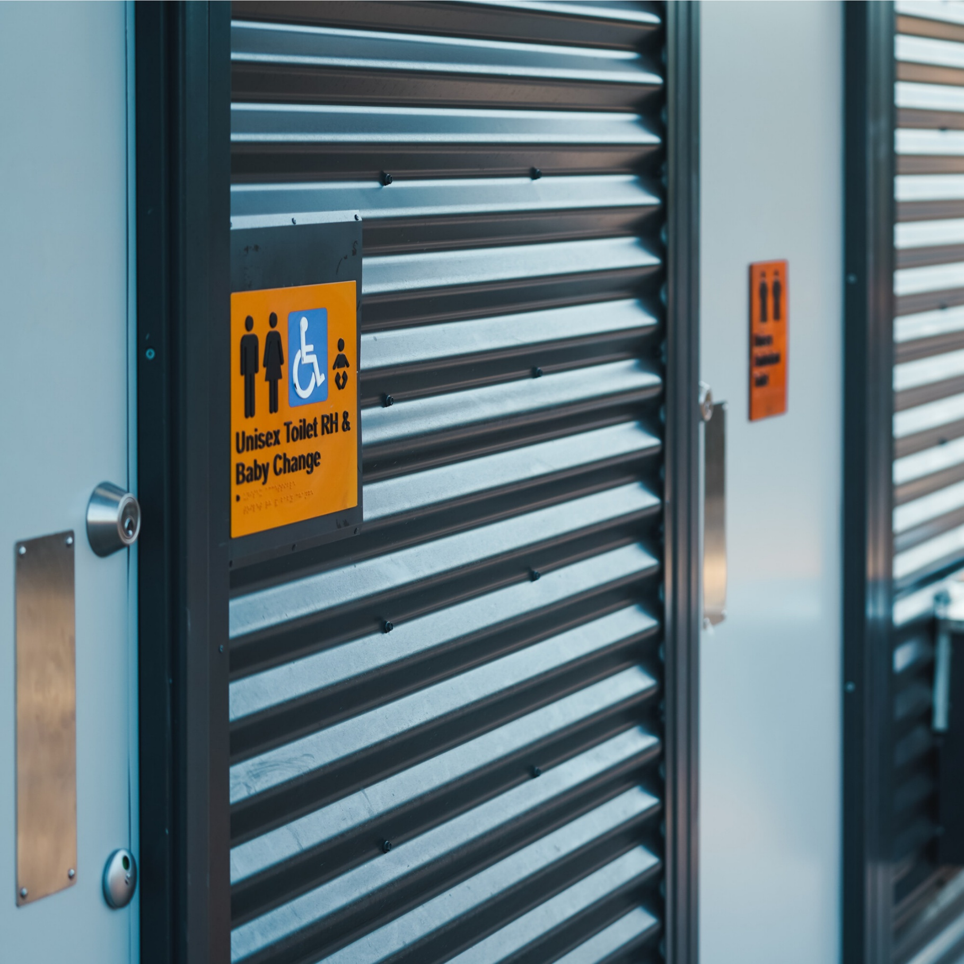


December 2025

Loyola Road Reserve Public Toilet: Round 2 Community Engagement Report

Engagement overview
Public toilets are important facilities that allow community members to enjoy open spaces comfortably and for longer periods of time. Council is proposing to install a new public toilet in Loyola Road Reserve in Werribee. Council previously engaged about this public toilet in 2023 and heard a range of feedback which was considered with changes being made to the proposed location.
Following a community petition against the proposed location a second round of consultation was undertaken in late 2025. Participants were invited to view the updated concept plan and detailed plan of the proposed location before providing feedback via an online survey on The Loop.
This consultation was open for four weeks from 3 November to 1 December 2025. Feedback from the engagement will help shape the final recommendation to inform whether Council considers this project for a future capital works budget in early 2026.
Throughout the engagement, we heard from 102 people with 66 (64.71%) in favour of building the public toilet at Loyola Road Reserve.
‘No’ voters were asked to elaborate on their concerns. Key concerns included potential antisocial or unsafe behaviour that a public toilet may encourage (24 counts), impacts on nearby residents such as privacy and noise (17 counts), risks of vandalism and maintenance issues (15 counts), traffic and pedestrian safety across Loyola Road (8 counts) and whether a public toilet is needed in this Park (13 counts).
The broad community support for the public toilet and the key concerns raised will help inform the next steps, ensuring that community views have been considered in decision-making.
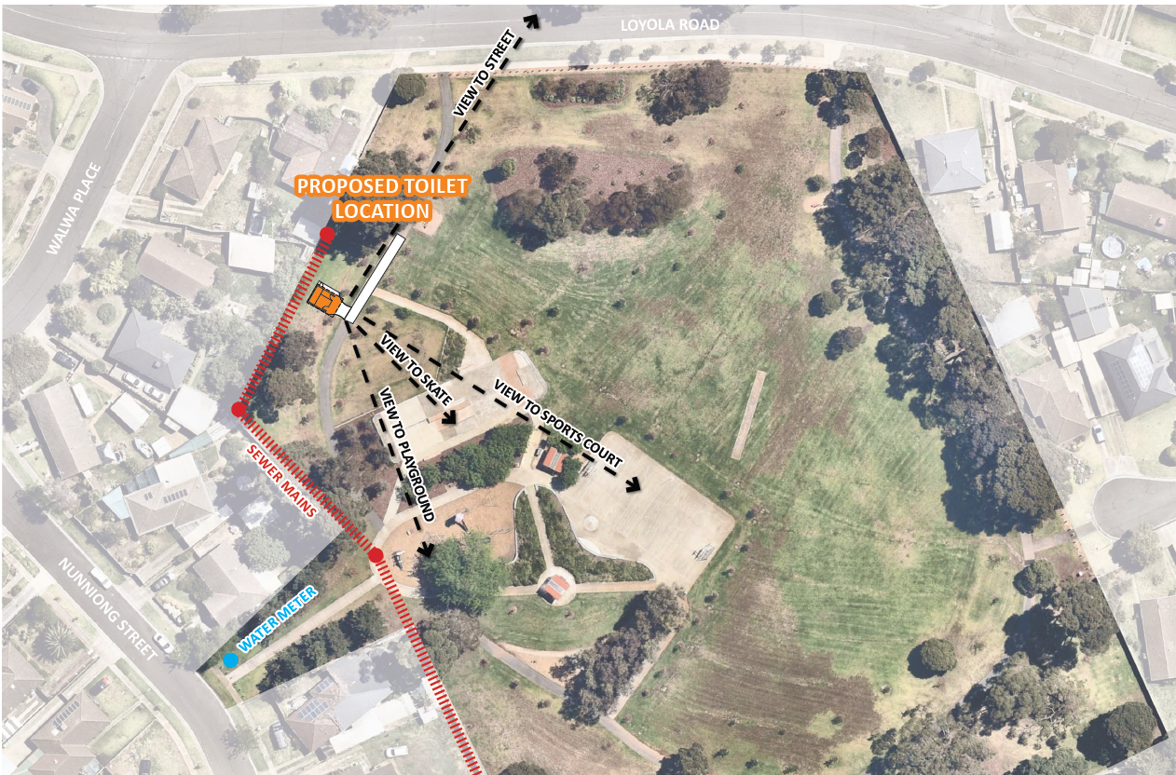

How did the community get involved?
  102 survey contributions |   1,411 page views on The Loop page |   876 total visitors to The Loop page |   2 direct emails
The below tables outline the ways we engaged with the community and the activities undertaken to promote the engagement.

Online promotion | A number of advertisements were run via social media. These included a mix of paid and organic advertisements.  - Reach: 43,534 people  - Engagement: 862

What did we hear?
In total, 102 surveys were completed. The below highlights the feedback received via The Loop online survey during the engagement process.

Question 1: Do you support the construction of a new public toilet at Loyola Reserve?

No – 35.29% (36 responses)
Yes – 64.71% (66 responses)

Question 2: Thanks for your response, do you care to expand?
This was a free text box that was not mandatory and only displayed for those who responded ‘no’ to the first question. The data has been themed as below. 34 people responded to this question. Some responses included more than one theme.
Theme | Percent | Count
Theme 1: Potential for antisocial / unsafe behaviour  Concerns that a public toilet will attract antisocial behaviour in the area including illegal activity, loitering, vandalism, noise, and unsafe behaviour from teenagers and non-locals, making the park feel less safe for families and children. | 52% | 24
Theme 2: Impacts on nearby residents  The proposed location is seen as too close to homes, affecting privacy, outlook, noise levels, personal security, and overall neighbourhood amenity. | 37% | 17
Theme 3: Potential damage and maintenance burden  Beliefs that the facility will be misused, vandalised or graffitied, creating ongoing repairs, rubbish and damage to existing park assets. | 33% | 15
Theme 4: Traffic and movement safety  Concerns that increased visitation will worsen parking congestion, hooning, and safety issues for children and pedestrians using Loyola Road. | 17% | 8
Theme 5: Not needed/wrong location  Beliefs that the toilet is unnecessary for a small local park where residents can go home if required, is inconsistent with other parks in the area, or should be placed elsewhere (e.g. closer to shops or further from homes). | 28% | 13
Total |  | 77

Next steps
Feedback will be combined with other data and inputs. An Officer recommendation will be provided to Council’s Executive Leadership Team, and Councillors, on the delivery of this public toilet, and to seek funding in a future financial year. The community will be notified of the outcome in Early 2026.

Appendix 1: Who did we hear from?
The below highlights who we heard from during our engagement via The Loop survey.
Age Group | % | Count
Under 12 | 2.94% | 3
12-17 | 0.98% | 1
18-24 | 3.92% | 4
25-34 | 11.76% | 12
35-44 | 28.43% | 29
45-54 | 21.57% | 22
55-64 | 16.67% | 17
65+ | 13.73% | 14
Total | 100% | 102
Gender | % | Count
Female | 55.88% | 57
Male | 41.18% | 42
Prefer not to say | 1.96% | 2
Other | 0.98% | 1
Total | 100% | 102
Suburb | % | Count
Hoppers Crossing | 4.90% | 5
Manor Lakes | 1.96% | 2
Point Cook | 0.98% | 1
Tarneit | 4.9% | 5
Truganina | 1.96% | 2
Werribee | 74.51% | 76
Werribee South | 5.88% | 6
Wyndham Vale | 4.9% | 5
Total | 100% | 102

Language | % | Count
English | 82.35% | 84
Urdu | 3.92% | 4
Mandarin | 1.96% | 2
Telugu | 1.96% | 2
Other | 9.8% | 10
Total | 100% | 102

Identity | Yes % | Yes count | No / Prefer not to say % | No / Prefer not to say count
A person living with disability and/or someone caring for a person living with disability | 21.57% | 22 | 78.43% | 80
An Aboriginal and/or Torres Strait Islander person | 2.94% | 3 | 97.06% | 99
A person who identifies as LGBTQIA | 2.94% | 3 | 97.06% | 99
Total | 100%

Appendix 2: Feedback from engagement
Below is the feedback received from the engagement Question 2: Thanks for your response, do you care to expand?
This was a free text box that was not mandatory and only displayed for those who responded no to the first question ‘Do you support the construction of a new public toilet at Loyola Reserve?’ 34 people responded to this question.
A toilet in this old park is not a good idea and is not required. There is high drug use in the immediate area which will only increase with a toilet/secluded shelter available. A toilet will dramatically increase patronage of the park, increasing traffic congestion along Loyola Road. There is already a high degree of risk associated with passengers (children) getting into/out of cars. With both sides of Loyola Road with parked cars, the road is very narrow. There is no pedestrian crossing or traffic management along this section of the road. Hoons do burn outs and speed along this road practically every day. A toilet in this park is a bad idea. | It's too close to residential housing.
Anti-social behaviours that require privacy will be drawn to the park. Non local users will be drawn to the park. Increase in free rubbish, including drug use paraphernalia, further damage to existing gardens and structures, graffiti. Parking congestion in adjoining streets. Motorbike users already do enough damage. | It's a park for local people; we can go home if we need a bathroom. Please put a public toilet near the 7 11 on Duncans Road for people to use.
As a resident of Loyola Rd for over 36 years I have seen the decline in social behaviour in the park, and it seems that the only people using the park are teenagers on motor bikes ICE/Elect and drug users. The bottom end of Loyola Rd has some of the most undesirable Riff Raff observed cutting up the park harassing residents with illegal behaviour and antisocial acts and the only one to benefit from this will be the contractors repairing the facilities when they are damaged. | Living behind where it is going it, I am against it, the noise the graffiti the disturbance, the smell also the people who are on drugs, I’m am a person with a lot of lung problems. When the skate park opened the disturbance we had with people and still there is trouble there. I can guarantee that none of the council lives close to the park and you all need to seriously think about what your doing, to the very close neighbour hood and what we will have to put up with, so it’s a stern no from me.
Building a new public toilet at Loyal Park presents significant safety concerns that should be carefully considered. Given the current situation where the park reportedly attracts individuals who are heavily under the influence of drugs, introducing a secluded facility like a toilet could inadvertently create an undesirable space for them to congregate or use. Furthermore, the existing lack of lighting in Loyal Park would compound this risk, potentially turning the unlit area around the toilet block into a dangerous and unsafe environment for all park users after dark. Ultimately, any development should prioritize the safety and security of the community. | Many other parks in Werribee do not have toilets.
Having a toilet in the park will only open it up for more vandalism and upset the ascetics of the park | No it will lose its appeal of being a nice clean park it does not need a toilet
I am a resident of Loyola Road & will have a clear view of the toilet from our back deck, kitchen window & back door. It is way too close to private property (i.e.. ours) while I am a big believer in toilets being included in all new park/playgrounds, to retrofit this one into a park surrounded by houses would be a big mistake. There is also a huge gum tree very close to where the toilet will be & I’d be keen to know if any thought has been given to ensuring none of the toilet installation work will impact the integrity of the tree. | not needed
I feel the park has a respectable locals attending regularly by adding toilets will certainly bring in unwanted behaviour. This area is young families & elderly and do not wish to have unwanted behaviour that public toilets bring with it. Also with where our house is the toilets will be our view which we certainly do not want | Private houses area
I just think it will be used for drugs and we don’t need anymore kids exposed to this. | Public toilets seem to be frequented by undesirables
I know my neighbourhood and what the youth and young adult community get up to when they’re bored. I anticipate that this will create another stomping ground for them to cause further mischief! | Stoop wasting money on crap and focus on a major swimming complex in Truganina!
I live right near the park and at the moment it is a beautiful, peaceful park most of the time.  Lately we have been getting teenagers on e-bikes hooning around the park which scares the younger children & is very dangerous. If toilets are placed there it will turn this park into a hangout for people and create more problems. | The park has great open space and caters for residents and their families, it does not need a public toilet that can potentially attract non-resident campers/squatters (similar to Werribee river area near and around Chirnside Park and Bungies Hole) and attract unsociable and illegal behaviour (drugs). Near by resident's would have an increased risk of confronting unsociable behaviour and personal security issues. Given the relative low profile of the Park vandalism of the toilet facility is also a significant risk.
It is too close to residences and will attract unsafe behaviours | This opens room for inappropriate behaviour(illegal activity) drugs deals / users etc, a lot of noise, uncleanliness, fowl odour and an unpleasant environment to live next two and unpleasant for park visitors.
it should be put in middle of park not near residents back fences | This park is quiet, with all sorts of people that walk through it. Occasionally you see a couple of children playing in the play area. I don't think a toilet is necessary as it is only something else for the vandals to get into. I feel the money would be put to better use cleaning up the gum leaves that fall all over the place in the streets from your trees.
it will attract louts and create noise | To close to my house. I can see it from my back deck. Any other location would be fine.
To close to the residential houses | To close to residential housing
Waste of money | Waste of money, not sure it would be used for anything other than illegal activity.
we need indoor pools | While it is a good idea to have public toilets are they going to have someone patrolling day and night as it may become another thing to vandalise or misuse.
Will create an area for junkies to hang around and loiter | Wyndham has sufficient number of parks. Everyone can access park nearby their homes unlike many older suburbs. Hence there shouldn’t be any toilets in parks that might attract unwanted guests taking longtime shelter. Toilets also encourage people to gather at one place rather than parks nearby their home and make it very uncomfortable for local kids to play there. So, no. Please never build any toilet in any Wyndham park. If you must then build them nearby servo.

