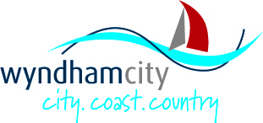


Accessibility Action Plan 2019 – 2022
Easy English Version

About this Document

You are important to us. We want you to:
- feel welcome
- to be included
- participate in life and activities in the community

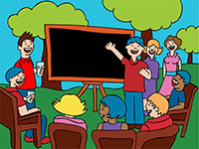 | We spoke with people with disability  - in the community  - employees at Council  - and services
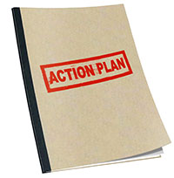 | This document is about Wyndham City Council’s action plan for people with disability
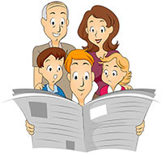 | This booklet is an easy read summary of the action plan
 | The action plan will start in 2019 and end in 2022
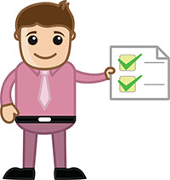 | We will report our progress for the actions each year

What the hard words mean

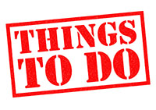 | Actions – what we will do
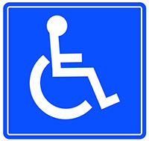 | Accessible – things that make it easier to join in
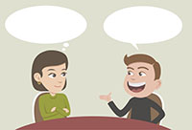 | Advocate – a person who explains what you need to someone else
 | Community – the people who live in our area
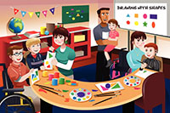 | Community Centre – a place where people go to do an activity
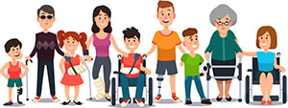 | Inclusive – thinking about everyone
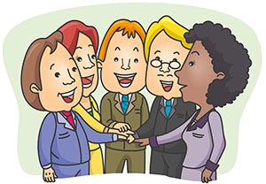 | Participate – making it easier to join in
 | Technology – things that make it easy to do things or get around
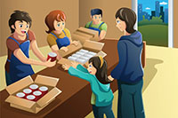 | Volunteers – people who help in the community
 | Website – a place where people get information online
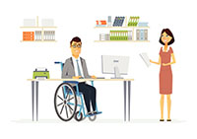 | Workplace adjustments – things to help you do your job

We want to make things better for you in 4 ways
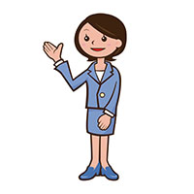 | - Making Council more welcoming of people with disability
 | - Making the community a better place for people with disability
 | - Making Council a better workplace for people with disability
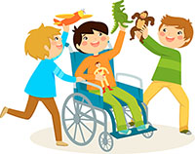 | - Making it easier for people with disability to join in

The things we do are called actions.
The actions are put into 4 areas.

- Our community is more inclusive of people with disability

Actions we will do:
 | - We will have a website that everyone can use
 | - We will have more things for people with disability in our libraries
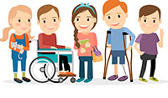 | - We will have better access to childcare and education for children
 | 4. We will improve customer support for people
 | - We will include more art from people with disability
 | - We will have more volunteers that are people with disability

- Places in Council are welcoming of people with disability

Actions we will do
 | - We will make our community centres more accessible for people
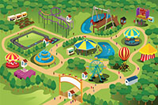 | - We will make our events more accessible for people
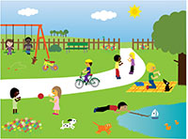 | - We will make our buildings, parks, and outdoor areas more accessible
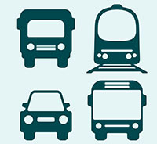 | - We will advocate for better transport
 | - We will use more technology to improve access
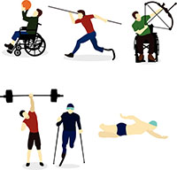 | - We will make sport and recreation more accessible

- Employment of people with disability is important

Actions we will do
 | - We want more people with disability to work for us
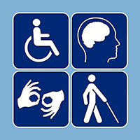 | - We will provide workplace adjustments for our employees
 | - We want our training to be accessible for everyone
 | - We will improve safety for our employees and community
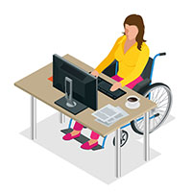 | - We encourage business in Wyndham to employ people with disability

- Participation of people with disability is important to us
Actions we will do

 | - We will talk to people with disability
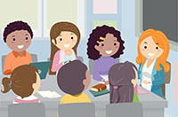 | - We will talk to disability services
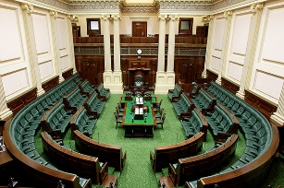 | - We will talk to State Government to influence better access
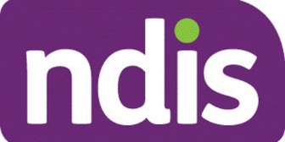 | - We will support the rollout of the NDIS
 | - We will get goods and services from people with disability
 | - We want feedback from people with disability

