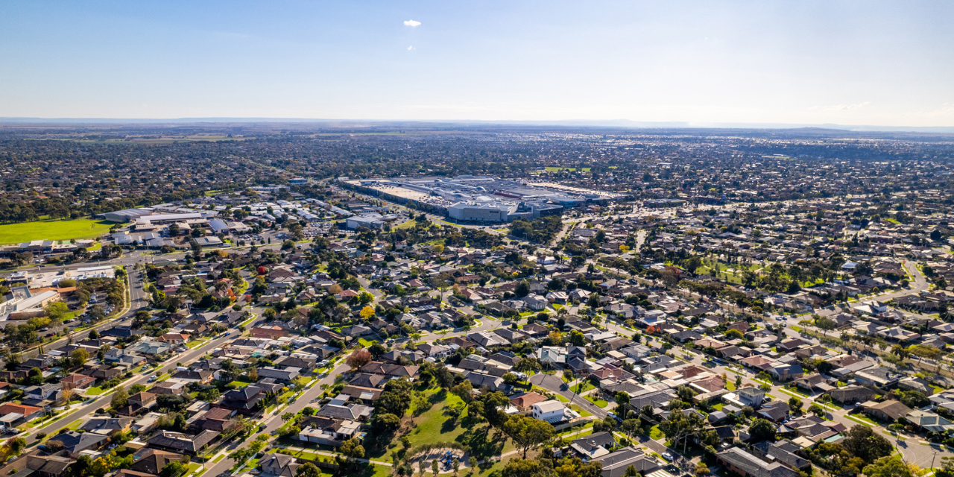
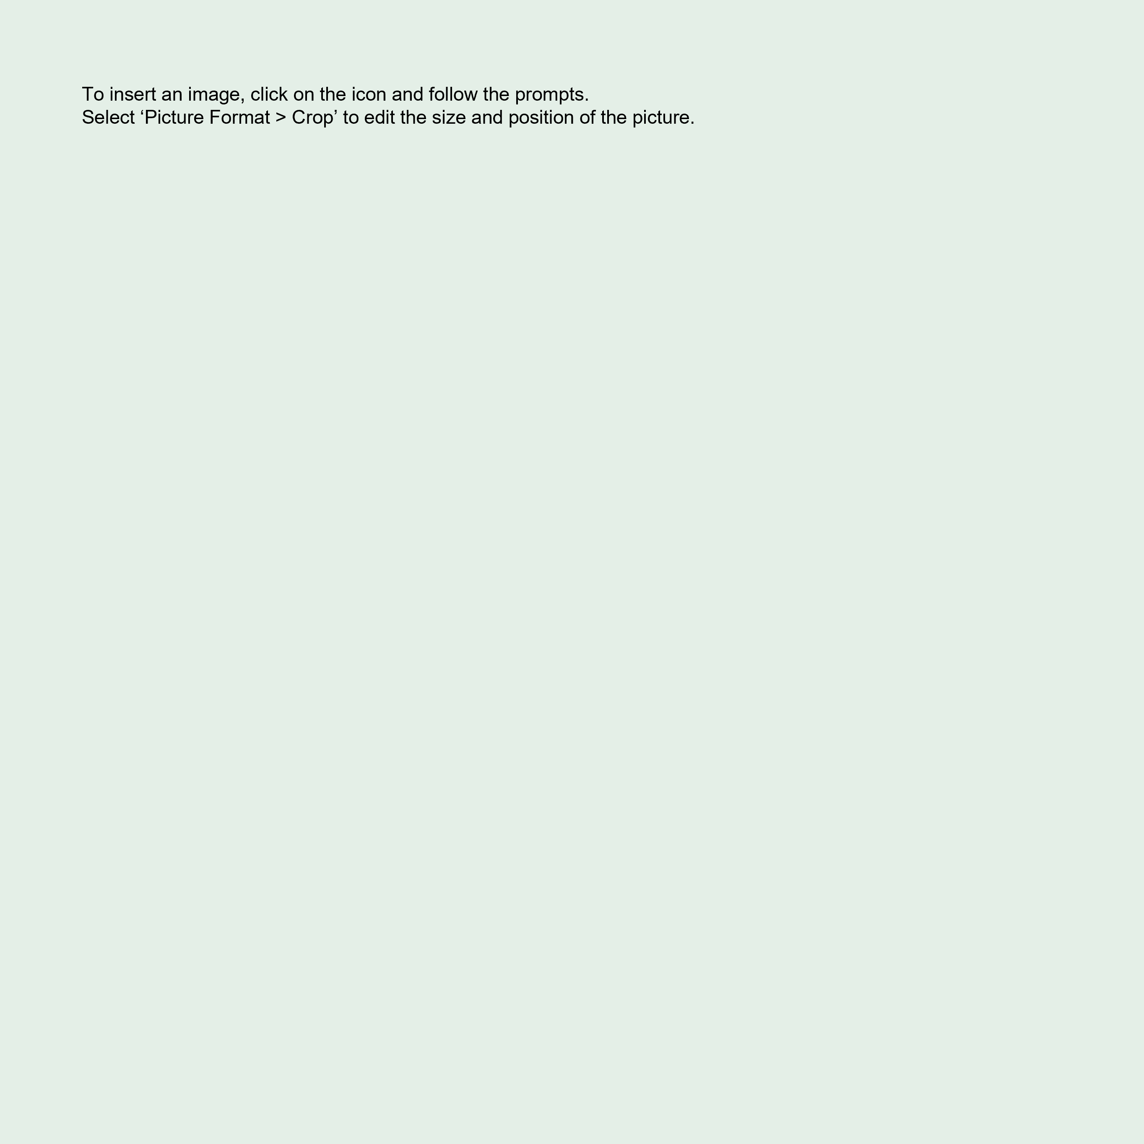


October 2025

Affordable Housing Background Paper

Acknowledgement of Country
Wyndham City Council recognises Aboriginal and Torres Strait Islander peoples as the first Peoples of Australia. We acknowledge the Bunurong and Wadawurrung Peoples as Traditional Owners of the lands on which Wyndham City operates. The Wadawurrung and Bunurong Peoples have and always will belong to the Werribee Yalook (river), creeks, stars, hills and red clay of this Country. We pay respect to their Ancestors and Elders who always have, and always will, care for Country and community today and for future generations.
Contents
Introduction 3
Housing and Health 4
Equitable Housing 5
Homelessness 5
Wyndham Community 6
Affordable Housing Need 10
Housing Stress 10
Housing Diversity 11
Housing Density 11
Rental Affordability 12
Housing Market 14
Social Housing 14
Key Worker/Essential Worker Housing 16
Policy Context 16
Australian Government 17
Victorian Government 18
Wyndham City Council 20
Future Options 23
Definitions 34
References 37
Appendix 40

Affordable Housing

Introduction
Wyndham City’s first Affordable Housing Strategy 2022-2025 has expired and Council is developing a new strategy to further advance affordable housing options in Wyndham over the next ten years, 2026-2036.
In our first Affordable housing Strategy we recognised the basic human right to housing. Fulfilling the right to adequate housing includes consideration by the State of the affordability and accessibility of housing, including protecting our most vulnerable community members.
When choosing our housing prior to the pandemic, few of us would have factored in the potential for isolation and loneliness, the need for separate work/study spaces, access to private green space, or the infection risk of shared lifts.
Bentley & Baker, 2020
Council takes a holistic view of health and wellbeing which includes housing, recognising that people’s physical, mental, emotional, and social wellbeing is largely determined by the environment - the broad range of conditions in which people are born, grow, live, work, age and people’s access to power, money and resources, which have a powerful influence on health inequities.
This Background Paper looks at a range of potential strategies for Wyndham to increase social and affordable housing supply. Wyndham needs homes that are affordable for people on very low to moderate incomes, including social and community homes where rents are subsidised making housing more affordable for those households.
Household Income is an important indicator of socio-economic status. Very low income for a single adult in Wyndham is $0 to $30,870, for a couple $30,871 to $49,380 and for a family $49,381 to $74,080. Over half (59%) of Wyndham households are on incomes ranging from very low to moderate.
Rents are rising, and doing so faster than incomes, inflation, and the broader cost of living. Between 2015 and 2025, the average rent in Melbourne rose by 56.8 percent. The surge in rents has coincided with a national failure to grow and maintain social housing.
Figure 1 - Availability of Affordable Home for a single person in Wyndham
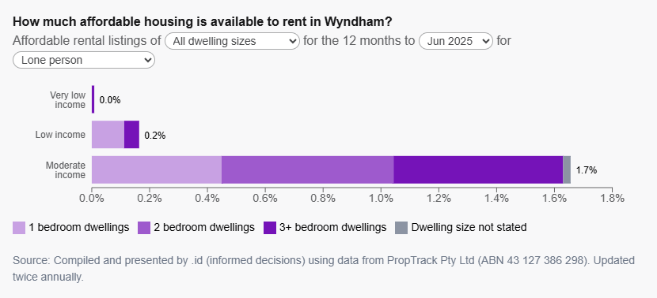
Covering an area of 542 square kilometres, Wyndham is one of metropolitan Melbourne’s designated growth corridors, occupying a critical gateway to Greater Melbourne for Victoria’s southwest. There will be continuing reliance on Wyndham and the western-northern growth areas of Melbourne, as well as surrounding regional cities, to accommodate a large portion of Victoria’s future housing needs. Wyndham is also a growing community with a current population of 337,009, expected to grow to 488,572 by 2046.

Housing and Health
The pandemic, especially during lockdowns, brought housing and health together in our minds. The World Health Organisation (WHO) has long been interested in housing as one of the social determinants, of health, having launched evidence-based guidelines for healthy housing policies in 2018.
Health equity is a guiding principle of the Council Plan incorporating the Municipal Public Health and Wellbeing Plan 2025-2029. Council takes a holistic view of health and wellbeing, noting that the conditions in which people are born, grow, live, work and age, and their access to power, money and resources, have a powerful influence on health inequities.
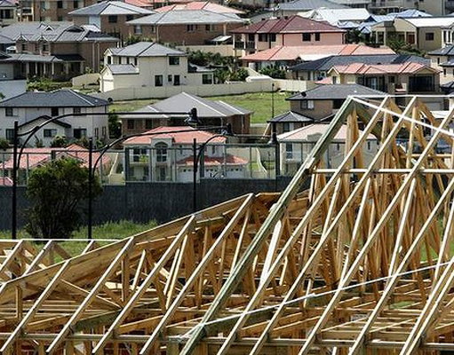
One study estimated that health costs due to respiratory and cardiovascular disease, attributable to mouldy or damp housing, is about three times the cost attributable to sugary drinks in Australia. Thus, these housing conditions stand alongside many of the classic risk factors such as diet, smoking and obesity.
Through its broad range of responsibilities Council can make an impact across a wide range of things that contribute to the health and wellbeing of its residents, including housing.

Equitable Housing
Ideally, everyone would benefit from improved cities, but in reality, the costs and benefits are not shared equally. Lower-income residents face undesirable options when looking for a home including, long commute times, overcrowded and/or substandard housing, and high rents or mortgages that limit available resources for other essentials. Not only do these families lose out on quality of life, in effect the whole community loses when economic diversity deteriorates.
For example, providing last resort housing to homeless people costs less than leaving them sleeping out.
- 75 per cent of the economic benefits of providing emergency accommodation would flow back to the community (the remainder to the individual)
- For every $1 invested in last-resort beds to address homelessness, $2.70 worth of benefits are generated for the community ($10,800 per year or $216,00 over 20 years).

Homelessness
Solving the housing crisis requires more than just increasing supply. The “missing middle” is not just a housing typology gap. It is a chance to fill a social gap.
Ziaesaeidi, 2025
The housing crisis is putting more people at risk of losing their homes and experiencing homelessness. Housing affordability is the most rapidly growing cause of homelessness in Australia, with the number of people stating housing affordability stress as a reason for seeking assistance rising from 19 per cent in 2013–14 to 36 per cent in 2023–24.
Figure 2 - Homelessness in Wyndham compared to Hobson's Bay, Melton and Brimbank
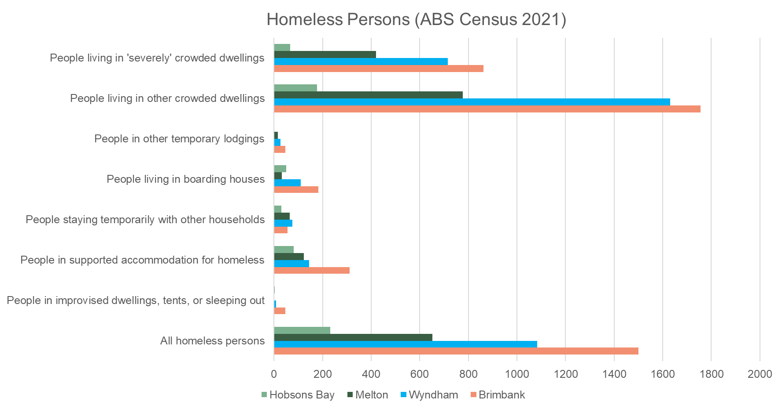
Currently, in Victoria social housing is 3.1 per cent of housing stock. After the Big Housing Build, it will be about 3.5 per cent, which is still well under the national average of 4.5 per cent (which itself isn’t enough to meet demand). Wyndham has very little social housing with less than one per cent (0.9%) of households renting social housing. Figure 1 above illustrates the extent of homelessness in Wyndham which is second only to Brimbank in the region.

Wyndham Community
In 2021, the usual resident population of the City of Wyndham was 292,011, living in 100,366 dwellings with an average household size of 3.07. Wyndham also had a higher proportion of children (under 18) and a lower proportion of persons aged 60+ years than Greater Melbourne. By 2031, the age structure for Wyndham indicates an 18 per cent increase in population under working age, a 48.5 per cent increase in population of retirement age, and a 35.9 per cent increase in population of working age.
For the period 2027 to 2031, migration is forecast to increase the population by 26,247 people. The greatest natural increase is forecast for the period 2042 to 2046, which is expected to have a net change of 26,805 people.
Figure 3 – Forecast Age Structure, Service Age Groups
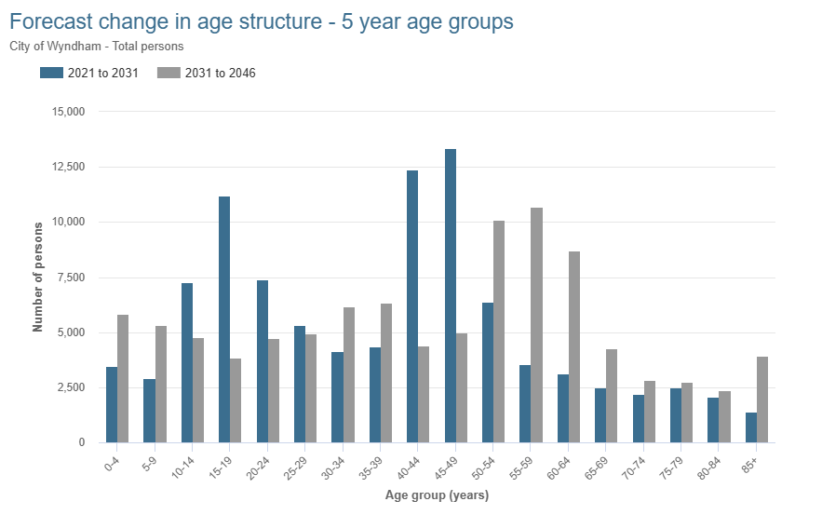
Ethnicity
When compared to Greater Melbourne, Wyndham has a more diverse population. 48 per cent were born overseas, compared with 35.7 per cent in Greater Melbourne. Around half (49.8%) of people used a language other than English at home. The three largest communities are Indian, English and Australian. The most common languages other than English are Punjabi (7.1%), Hindi (4.8%), Mandarin (3.6%), Urdu (2.9%) and Telugu (2.5%).
Labour Market
When compared to Greater Melbourne, Wyndham had a lower proportion in employment, and a higher proportion unemployed. 93.2 per cent of the labour force was employed, and 6.8 per cent unemployed, compared with 94.7 per cent and 5.3 per cent respectively for Greater Melbourne. 135,829 residents were employed, with 62 per cent in full-time and 31 per cent in part-time work.
Wyndham residents are well educated. Compared to Greater Melbourne, Wyndham had a similar proportion of people holding formal qualifications, and a lower proportion of people with no formal qualifications. Overall, 57.7% of the population aged 15 and over held educational qualifications, and 34.1 per cent had no qualifications, compared with 57.6 per cent and 35.2 per cent respectively for Greater Melbourne.

Figure 4 - Resident Worker Occupations
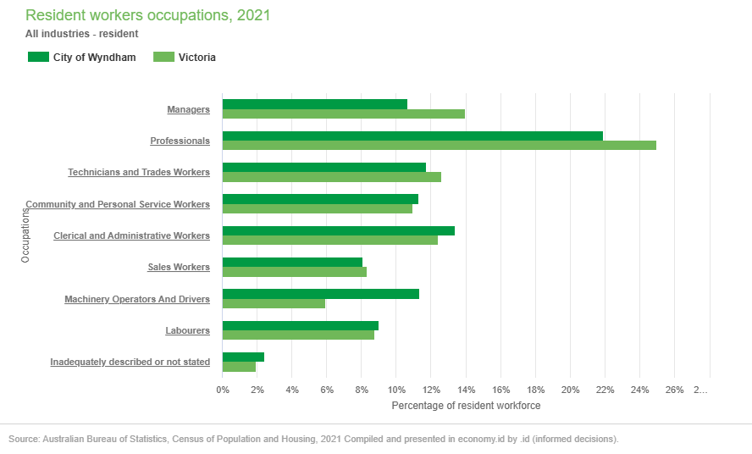
Wyndham had more residents that are professionals than any other occupation. The Health Care and Social Assistance sectors employ the majority of the resident workforce. The largest local employer was the Transport, Postal and Warehousing sector, generating 16,339 local jobs in 2023/24. The three most popular occupations were:
- Professionals (29,780 people or 21.9%)
- Clerical and Administrative Workers (18,225 people or 13.4%)
- Technicians and Trades Workers (15,967 people or 11.8%)
There are 87,491 local workers in the City of Wyndham. Of these, more than half live in Wyndham (49,888 workers, 57% of workforce). The other 43 per cent (37,603) travel into Wyndam for work. Most of the local resident workforce is young with over half aged 25 to 44 years. 25.2 per cent are aged 25 to 34 years, and a further 25.9 per cent are aged 35 to 44 years.
Monetary distance is more than just monetary distance. It comes with social distance.
Thomas Picketty, 2025
When compared to Victoria, Wyndham had a lower proportion earning a high income (those earning $1,750 per week or more) and a higher proportion of low income persons (those earning less than $500 per week). Less than a fifth (17.4%) of the local workers earned a high income, compared with 22.5 per cent for Victoria.

Wyndham Households
The size of households in general follows the life cycle of families. Household size is also influenced by the amount of affordable housing (lack or abundance). The number of households in Wyndham increased by 23,909 between 2016 and 2021. The age group with the highest net migration in Wyndham is 25-29 year olds, forecast to occur between 2026 to 2031.
The dominant household structure in Wyndham is family households, couples with children. 46.4 per cent of households were made up of couples with children, compared with 33.1 per cent in Greater Melbourne. Wyndham also has a higher proportion of single parent households, 11 per cent, compared with 10.2 per cent for Greater Melbourne.

Household Size
Generally, in Australia, household sizes have been falling since 1910, when the average size was 4.5 people. A quarter (26%) of households are now occupied by one person. The decrease in household size is due to more couples having fewer or no children, and the increase in people living alone.

Figure 5 - Lone Persons by Housing Type
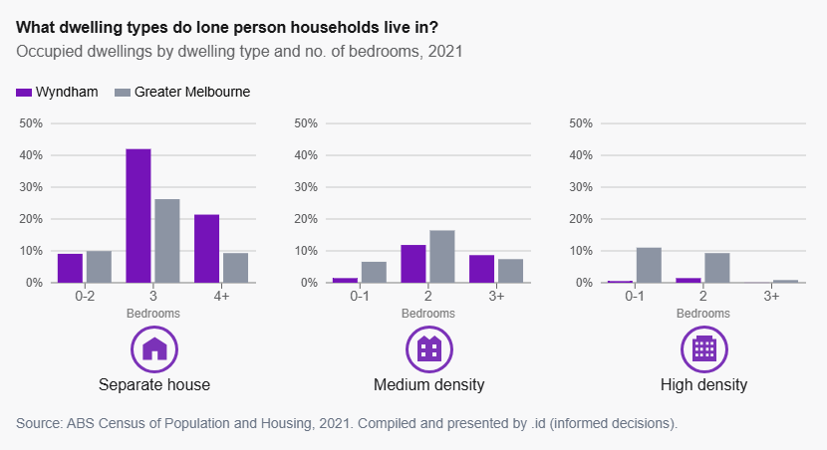

In Wyndham, 15.2 per cent (13,668) of households were single person households. Almost a fifth (24.7%, 22,179) are households with 2 persons per household. This means that the type of housing available in Wyndham does not match the needs of over a third of residents (39.9%).
Due to the cultural diversity of the resident population, Wyndham also has many intergenerational households and therefore larger households. Wyndham has a higher proportion of larger households (4+ persons) when compared with Greater Melbourne (38.5% and 27% respectively).
The Australian Bureau of Statistics (ABS) classes overcrowding as a component of marginal housing that does not meet 'minimum expectations' of housing. People who are marginally housed may be at risk of homelessness in the future. The vast majority of residents who are marginally housed (98%) in Wyndham are in overcrowded dwellings.

Figure 6 - Marginal Housing in Wyndham
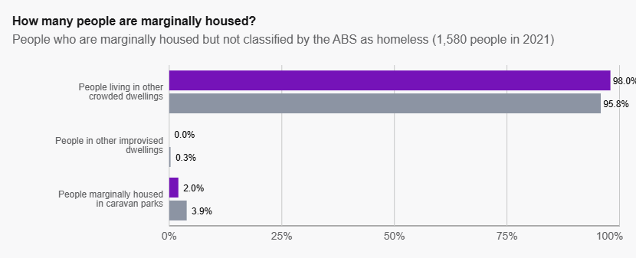

Affordable Housing Need

Housing Stress
Housing stress is a tangible measure of how many households may be in financial difficulties, and directly correlates to housing affordability. If many households are in housing stress, it directly indicates that housing is unaffordable. However, many people may also need to live in Wyndham, and so are paying this anyway.
Figure 7 - Mortgage Stress by Income and Area
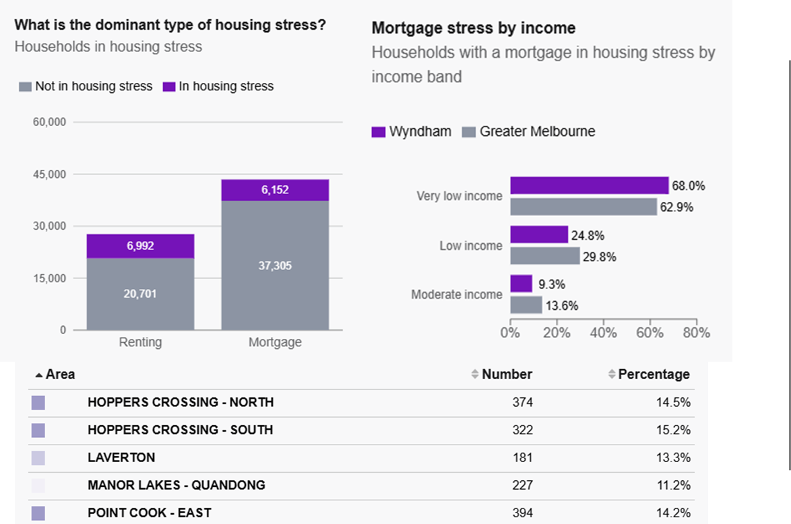

6,093 Wyndham households including 2,012 families need affordable housing. 13,144 (14%) of Wyndham households are living in housing stress.
- 6,992 households are in rental stress
- 6,152 households are in mortgage stress

Housing Diversity
Wyndham has little housing diversity. The dominant dwelling type is large separate dwellings of four bedrooms and more (49.6% of housing stock).
Figure 8 - Housing Diversity in Wyndham
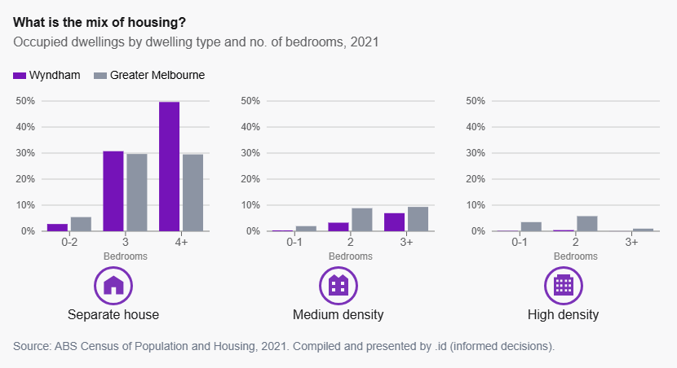
Wyndham has fewer medium density dwellings when compared with Greater Melbourne (11.5% and 21.6% respectively), and fewer high density dwellings (0.7% and 12.8% respectively). In Wyndham:
- 87.3% of dwellings have three or more bedrooms
- less than one per cent (0.7%) have one-bedroom
- less than 7 per cent (6.2%) have two-bedrooms

Housing Density
Medium density housing, sometimes referred to as the ‘missing middle’, has the potential to better facilitate liveability through social connection within urban and suburban communities. Higher density housing, properly implemented near activity centres, can enable social interaction and walkability, while inclusive urban design can ensure that increased density supports, not only the quantity of housing, but also the social quality.
Enabling more diverse housing forms within walkable distances of local centres and public transport encourages more vibrant, mixed communities where people are more likely to interact in shared spaces.

Rental Affordability
Families without paid work are priced out of the rental market. Across Victoria less than one per cent (0.8%) of properties (127 of 16,219 individual properties) were suitable for at least one household type living on income support payments. Since 2024, this is a decrease of 28 per cent. 19.2 per cent (2587) of properties were suitable for at least one household type living on minimum wage without placing them in housing stress. Based on the number of houses available in 2025 across metropolitan Melbourne, Wyndham does not appear in the ten most affordable local government areas (LGAs) for households on income support.
The Victorian Government's Big Housing Build includes 12,000 new social and affordable housing units over the next four years. However, that supply line falls well short of the number of new homes required to meet population growth and is failing to supply homes that are affordable for the renters in the lowest income quintiles. It is also failing to supply homes in Wyndham.
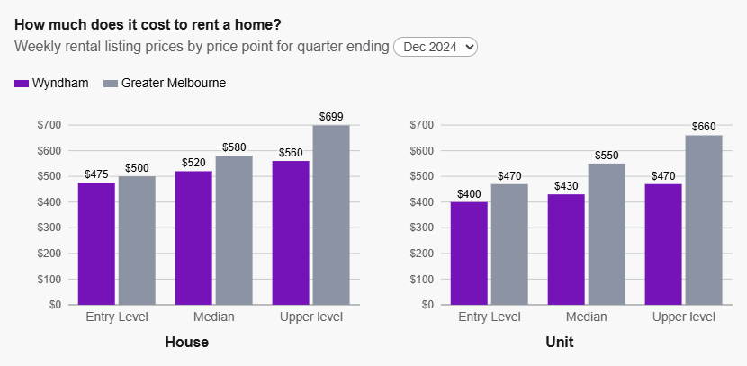
Figure 9 - Weekly Residential Rents

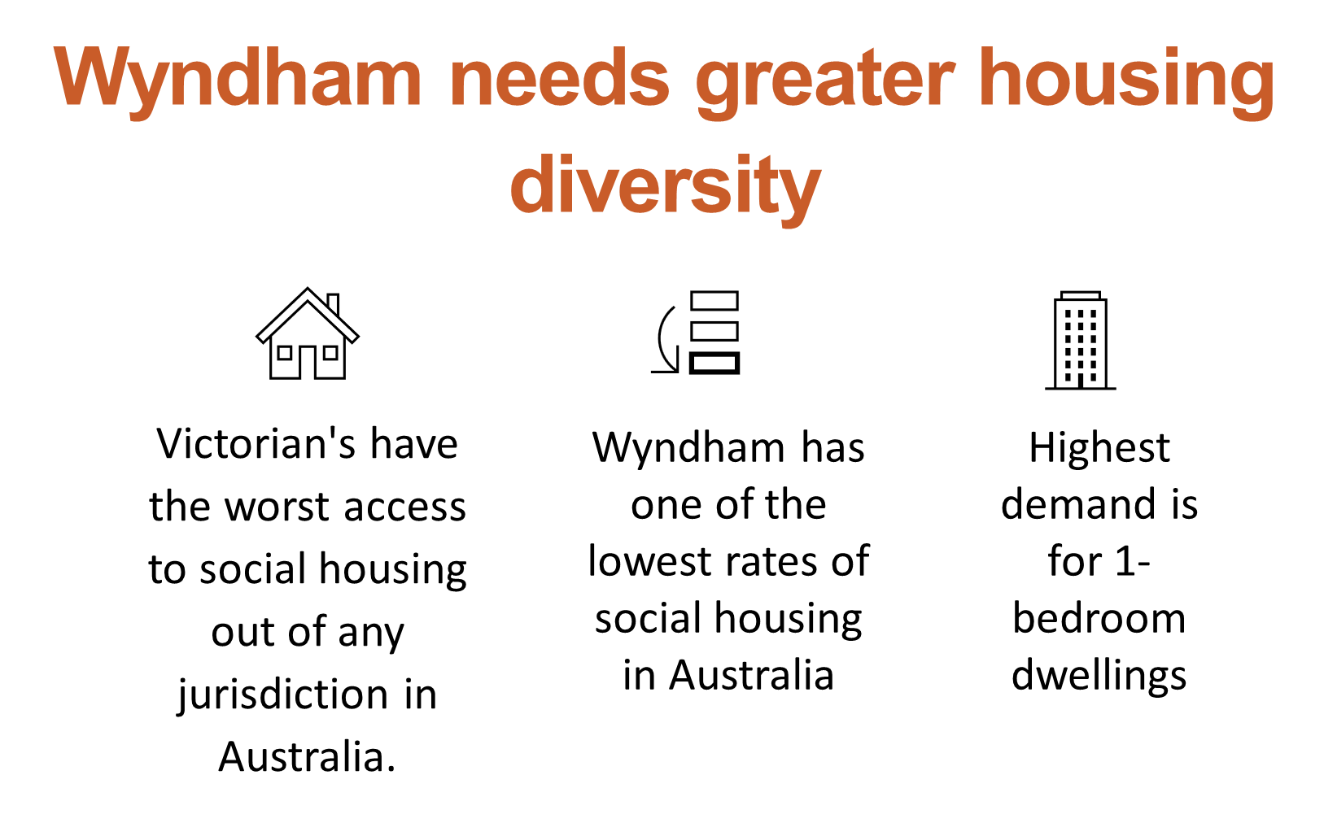
Homes Victoria has a good understanding of current and future demand for housing. However, the Victorian Auditor General’s Office (VAGO) found that the department does not always use this information to identify the areas with the highest need.
The Homes Victoria model shows that the LGAs with the highest demand included Wyndham City with the data predicting that by 2036 the greatest demand will be in the Cities of Wyndham, Melton, Casey, Melbourne and Whittlesea. Subsequently, VAGO found that there is a risk that Homes Victoria may not be using a statewide view of housing demand to inform and prioritise its local decision-making.
The state governments’ program of urban renewal includes demolition of the public housing towers in Melbourne. The displacement of so many households is having a major detrimental impact on wait lists for social housing (Victorian Housing Register) across Melbourne, including Wyndham. Local impacts were reported to Council via members of the Wyndham Health, Homelessness and Housing (H3) Alliance, convened by Council.
Figure 12 - Building Approvals 2013-2025
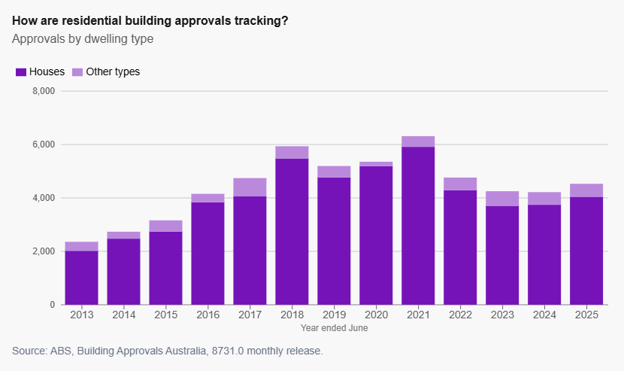

Housing Market
Households who were once safely housed in public or social or community housing compete for homes in a market that is already overcrowded and overheated. In effect, the private residential rental market has been left to do the heavy lifting, despite being fundamentally unsuited to the task of providing long-term, affordable housing for lower income households.
The supply of new housing nationally is near its lowest level in a decade. While there is consistent delivery of housing in Wyndham, the majority of new homes are separate houses of 4+ bedrooms provided by the private sector.
Since 2021, there has been a downward trend in development application approvals with approvals dropping from 5,913 in 2021 to 4,044 in 2025. This reduction may indicate supply challenges in the market, adding to potential affordability issues.
Figure 10 - Housing Market and Cost
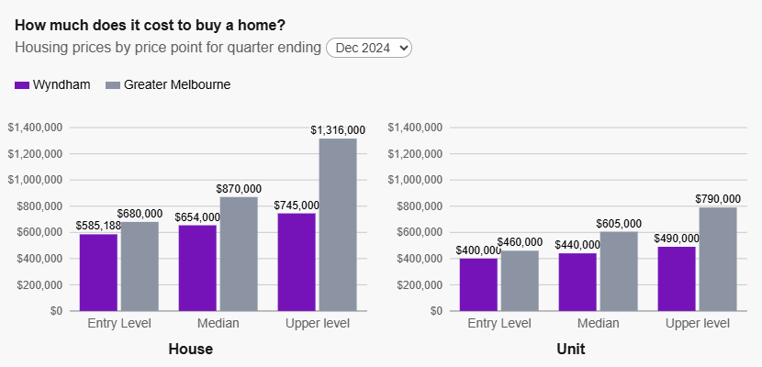

Social Housing
Many households are unable to find housing in the private market. Despite Victoria’s landmark four-year Big Housing Build, decades of under-investment in social housing by previous governments has left our state with the lowest proportion of social housing in Australia.
Providing social housing not only improves people’s health and quality of life, it relieves pressures on other government services, such as health, mental health, justice, and specialist homelessness services, which can be costly to provide.
Australian governments have underinvested in social and affordable housing for decades. There is an acute shortage of low-cost rental housing and the forecast is not encouraging with levels expected to remain, very low, relative to historical levels. In 2021, 3.8 per cent of Australian households lived in social housing, which is lower than in New Zealand (4%), Canada (4.2%) and the European Union (EU). The four highest results from the EU were Netherlands (29.1%), Austria (24%), Denmark (21%) and Sweden (17%).
Victoria has one of the lowest levels of social housing in Australia at 3.1 per cent of housing stock. In Wyndham, the proportion households in social housing is low (0.9%). There is not enough social housing for everyone who needs it. Wyndham is identified by VAGO as an area with high social housing demand. The decline forces more people into the private residential rental market, intensifying competition and driving prices higher across the board.
Victoria needs to build 7,990 new social housing dwellings a year for the next 10 years. The main problem affordable housing products seek to solve is that our private residential rental sector has been "going upmarket" for decades. That is, generating fewer and fewer homes affordable for people with low to moderate income who are ineligible for social housing.

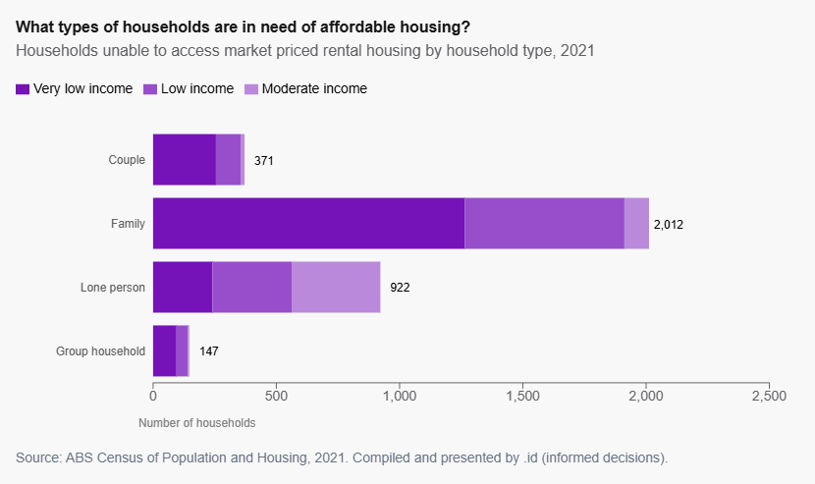
Figure 11 - Affordable Housing Need: Very Low to Moderate Income Households

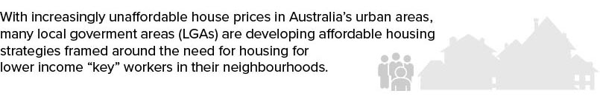
Key Worker/Essential Worker Housing
Low-income workers are essential to the operation of the modern urban economy, but may not qualify for social or community housing tenancy. This is a primary reason why Australian governments are taking growing interest in enabling affordable rental housing that could make it possible for people in this situation to live reasonably near their work.
Pandemic impact
Lasting legacies from the COVID-19 pandemic still influence the Australian construction sector and are likely to continue for many years to come. The pandemic significantly impacted both the global economic landscape and construction markets. Businesses have had to adapt to navigate within an environment of substantially higher risk.
The pandemic’s disruption of global supply chains, including the impact of transport restrictions and factory closures, has had growing repercussions on construction operations. There have been shortages of raw materials, subcontractors and labourers.
Practices within the sector have adapted to ensure resilience to future supply chain disruptions. This includes greater reliance on domestically sourced materials with many contractors purchasing materials in advance.
Tiffany Emmett, Project Director, Construction Economics, Turner and Townsend, June 2024.

[Cite your source here.]

Policy Context
State and Federal Governments have taken a range of actions to address the housing crisis across Victoria and Australia. Disruption impacts created by the pandemic linger.
Wyndham City seeks to address housing affordability through its strategic planning framework including the Wyndham Planning Scheme, the Wyndham Plan (2024), the Housing and Neighbourhood Character Strategy (2024) and the Affordable Housing Strategy 2022-2025 (expired).

Australian Government
National Rental Affordability Scheme
The National Rental Affordability Scheme (NRAS) was introduced to increase the supply of affordable rental dwellings. The scheme is winding down and ends in June 2026.
National Agreement on Social Housing and Homelessness (NASHH)
The NASHH is an agreement between the Commonwealth and state and territory governments, under the Federal Financial Relations Act 2009. It replaced the National Housing and Homelessness Agreement from 1 July 2024. Under the agreement, the Australian Government provides around $1.8 billion each year to states and territories. This includes a homelessness funding component of around $400 million a year. States and territories are required to match their share of homelessness funding
National Housing Accord
The Accord is one component of the government’s broader housing agenda. The Commonwealth and states and territories agreed to a target of 1.2 million new well‑located homes over five years from 2024. National Cabinet endorsed the Commonwealth providing $3.5 billion in payments to state, territory and local governments to support the delivery of new homes towards this target.
State and territory governments have agreed to build on this commitment to support delivery of up to an additional 10,000 affordable homes, enabling delivery of a combined total of up to 20,000 affordable homes under the Accord. The Victorian Government has agreed to build 2,546 affordable homes.
Through the National Housing Accord Facility (NHAF), Housing Australia provides loans and grants for projects that increase the supply of affordable housing across Australia, including regional, rural and remote areas.
Housing Australia
Housing Australia is the independent national housing agency. It administers the following.
- Australian Government 5% Deposit Scheme - supporting eligible home buyers.
- Affordable Housing Bond Aggregator - low-cost long-term loans to registered community housing providers for social and affordable housing.
- National Housing Infrastructure Facility
There are three components to the National Housing Infrastructure Facility.
  - National Housing Infrastructure Facility Critical Infrastructure (NHIF CI) provides finance for critical infrastructure to unlock and accelerate new housing supply.
  - The NHIF Social and Affordable Housing (NHIF SAH) provides concessional loans, grants or combination of to directly support new social or affordable housing projects.
  - The NHIF Crisis and Transitional (NHIF CT) provides concessional loans, grants or combination of to support the delivery of new crisis and transitional housing projects for vulnerable Australians.
- Housing Australia Future Fund
  - Established under the Housing Australia Future Fund Act 2023, the Housing Australia Future Fund (HAFF) was established with $10 billion. It provides additional funding to support and increase social and affordable housing, and other acute housing needs including, the needs of Indigenous communities and housing services for women, children and veterans.
  - Under the Act, the Future Fund Board of Guardians (the Board) is responsible for deciding how to invest the Fund and must seek to maximise the return earned on the Fund over the long term, consistent with international best practice for institutional investment.
Tax Incentives for Build to Rent (BTR)
On 1 January 2025, new income tax concessions in the BTR housing sector came into force, offering incentives for investment and construction in the sector, designed to increase the supply of housing by supporting BTR developments.
Eligibility for the new lower rate of withholding tax offered is conditional on a proportion of apartments in qualifying projects being made available at affordable rents, i.e. discounted from the market rate. Rents may be set at market rent or, for affordable housing, at an appropriate discount to market rents. This option can also be suitable for key worker housing.

Victorian Government
Victoria’s Planning System
Part of the State Government’s significant reform agenda, intended to implement Victoria’s Housing Statement: The decade ahead 2024-2034, included the Consumer and Planning Legislation Amendment (Housing Statement Reform) Bill 2024. The Bill proposed changes to the Planning and Environment Act 1987 (PE Act) and the Victorian Civil and Administrative Tribunal Act 1998 (VCAT Act). This legislation affects the planning scheme amendment process, permit application process, metropolitan planning levy, VCAT review and Planning Panel procedure, and planning compensation

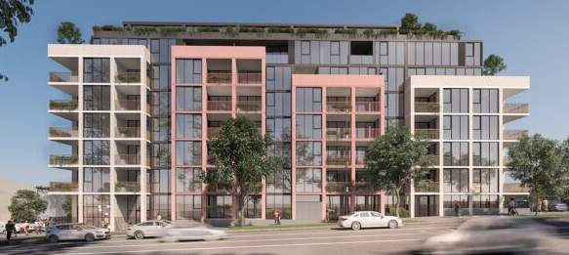
Victoria’s Housing Statement
Housing Key Workers and Build to Rent (BTR)
BTR is the process of developers building multi-unit buildings and, instead of selling the units, retain them to rent to tenant households. It is established practice in the United Kingdom, Canada and the United States of America.

It is seen in Australia as a potential solution to increase the supply of rental housing. State and Federal governments offer tax incentives to encourage BTR developments. It is viewed as, not only as an alternative residential platform in the Australian property market but also as an alternative investable asset class.

The City of Melbourne Adderley Street development (architects impression below) features 105 purpose-built rental apartments – a mix of studio, 1- 2- and 3-bedroom apartments. 50 percent of the apartments are designated affordable housing to support key workers in the city and surrounding major employment hubs including the Victoria Police Centre, Royal Melbourne Hospital precinct and the University of Melbourne.
Victoria’s Housing Statement, The Decade Ahead 2024-2034, focuses on five key areas to tackle housing supply and affordability in Victoria.
- Good decisions, made faster – planning system reform including for activity centres and building a second home on the same lot.
- Cheaper housing, closer to where you work – unlock and rezone surplus government land including industrial land at Werribee Junction (due diligence only).
- Protecting renters’ rights – portable rental bond scheme, security over leases, and establishing the Rental Dispute Resolution Victoria and Rental Stress Support Package.
- More social housing – including public housing tower replacement in metropolitan Melbourne.
- A long-term housing plan – Victoria’s responsibilities under the Commonwealth’s National Housing Accord working together with the Housing Statement to tackle housing supply and affordability.
Tax Incentives for Build to Rent (BTR)
Eligible BTR developments receive a 50 per cent reduction on the taxable land value for land tax and a full exemption from the Absentee Owner Surcharge for up to 30 years. In addition, the Affordable Housing Investment Partnerships (AHIP) program offers low interest loans and government guarantees available to finance BTR developments that include affordable housing.

Wyndham City Council
Wyndham is a geographically large municipality with a dispersed grouping of residential suburbs. As a result, many Wyndham residents travel significant distances to access jobs, services, cultural events and facilities. Council has a robust planning framework to guide housing and land use outcomes.
The challenge is to better connect Wyndham neighbourhoods and at the same time offer residents and prospective residents a wider range of housing options for quality of life, health and wellbeing. Wider housing options means greater housing diversity, including the ‘missing middle’ – medium density housing – close to transport and services supporting state government policy. Our suite of planning policies seek to meet this challenge and especially to increase the availability of 1- and 2-bedroom homes.
The Wyndham Plan
As Wyndham grows towards a population of almost 500,000 people by 2046, it needs to transform from dispersed suburbs to become a more cohesive urban area. The direction of the Wyndham Plan is to create a city of 20-minute neighbourhoods. This is also a key policy direction for the state in Plan for Victoria.
The goals of the Wyndham Plan are to increase Wyndham’s connectivity, and its dwelling mix to better reflect Greater Melbourne with increased residential densities offering greater housing choice. Wyndham Planning Scheme Amendment C266wynd updated the Municipal Planning Strategy to align with The Wyndham Plan to provide a strategic framework to guide future development within the City of Wyndham.
Wyndham Housing and Neighbourhood Character Strategy (2023)
This Strategy comprises a 15-year plan to manage housing growth and change across the municipality. The strategic vision is for Wyndham to be a destination of choice by 2040, with attractive residential areas providing a range of housing to meet the diverse needs of our growing population now and in the future. As our urban footprint expands, we plan to protect our unique natural environments by encouraging medium and higher density housing in well-located activity centres.
The Strategy has four housing principles.
- Housing choice for everyone
- Locate new homes in key centres, with existing services and infrastructure
- Enhance neighbourhood and landscape character to contribute to Wyndham’s unique landscape
- Protect and enhance our natural environment for future generations
Unfortunately, due to sweeping changes at the State Government level in relation to Victoria’s Housing Statement, the planning scheme amendment to implement the Housing and Neighbourhood Character Strategy is on hold awaiting further direction from the State Government.
Figure 13 - The 20-minute neighbourhood. Department of Transport & Planning, 2021.
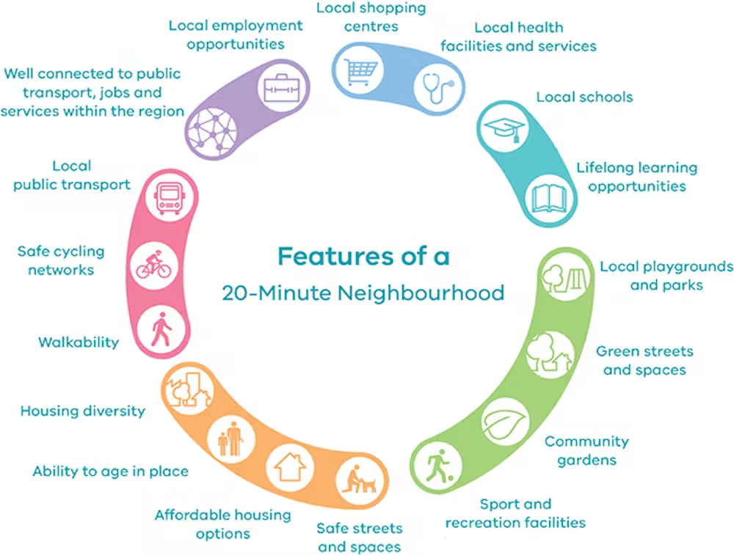

Wyndham Planning Scheme
The Wyndham Planning Scheme comprises state and local planning policies, zoning maps and planning controls which specify how land in the municipality may be used and developed. Council’s strategic direction for housing diversity is to increase the supply of one to three bedroom dwellings and the diversity of housing. At the same time, the Planning Scheme recognises the need for increased supply and diversity of social housing in infill and greenfield areas.
Council’s strategic directions for residential development are to:
- Accommodate a projected population of about 425,000 people by 2040
- Identify the Werribee City Centre as a key commercial and residential centre for Melbourne’s west
- Promote multi-level development near rail stations
- Encourage higher density development in activity centres
- Identify the Princes Highway corridor as an area where higher scale and higher density residential development may occur

Wyndham Affordable Housing Strategy 2022-2025
The Wyndham Affordable Housing Strategy 2022-2025 was reported on annually in Council’s annual reports published online. The Strategy pre-dated the Wyndham Housing and Neighbourhood Character Strategy and The Wyndham Plan, leading the way in prioritising greater housing diversity for Wyndham as well as density consolidation in activity centres. Refer to the appendix for key achievements of the Strategy in 2022 to 2025.
The Strategy was prepared in response to identified diverse housing need from 2019. Its main objective was to progress and guide Council’s future work for social and affordable housing, setting the groundwork for future social and affordable housing development in Wyndham. The Strategy was instrumental in supporting social housing development in Wyndham including the Unison development at Cottrell Street (apartments) and the Haven Home Safe development at Stewart Drive, Werribee (town houses).
The next Affordable Housing Strategy
The funding, delivery, and management of affordable housing is complex, involving multiple players within different operating contexts. The first Strategy demonstrated the value of coordinated action by laying the foundations for the next stage of social and affordable housing development in Wyndham.
Advocacy, planning scheme amendments, the H3 Alliance and the building of strong relationships across the organisation and with the community housing sector during the life of the previous strategy have positioned Council for future social and affordable housing options for Wyndham.
During the life of the Wyndham Affordable Housing Strategy, housing policy at state and federal levels was fast moving in response to the housing crisis. This includes greater collaboration between the Commonwealth and state governments through various agreements, funding mechanisms, and coordinated strategies to improve housing affordability and supply.
The Housing Continuum
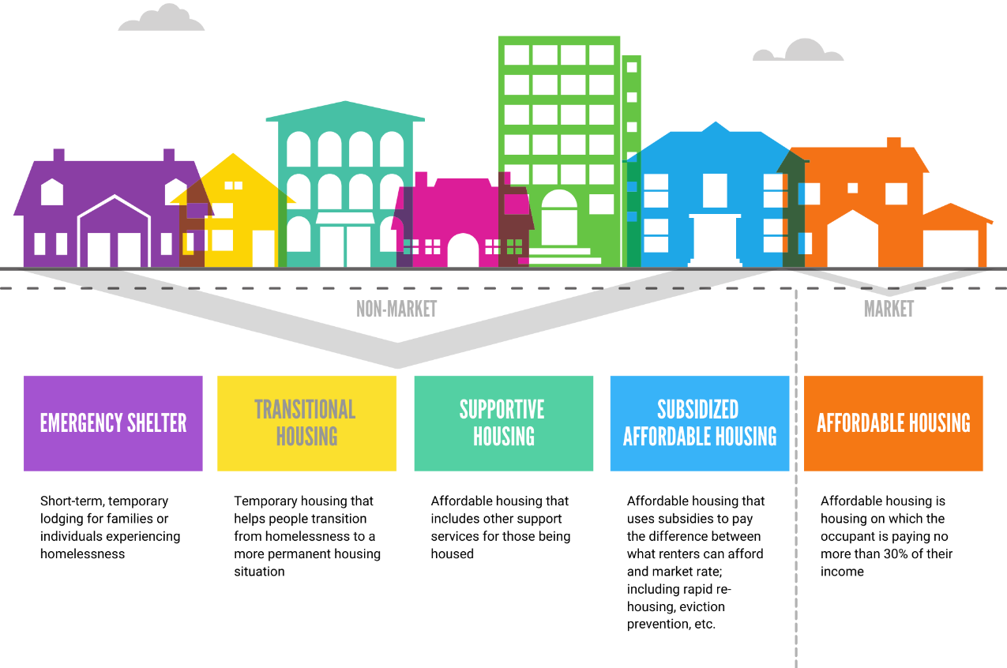

Future Options
The housing crisis is real and impacting on many local people and people who want to live in Wyndham. The option not to act can be costly. Without intervention, the shortages of social and affordable housing will continue. Wyndham City is in the business of creating a healthy, inclusive and prosperous community where everyone can succeed. No level of social exclusion, where households that cannot afford to live in Wyndham are forced out, is acceptable.
Many Victorian Councils are not waiting for other levels of government to act. While various factors impact housing supply (i.e. markets, affordability, availability), many are outside of the direct control of local government. However, Council can make decisions and act in ways that influence housing stock and supply in Wyndham. Council’s range of existing roles and responsibilities can be expanded to support the provision of social and affordable housing in new developments across Wyndham. Our planning mechanisms for example, determine what can be built where.
Council’s Key Areas of Responsibility
The next Wyndham Affordable Housing Strategy will be informed by the community, research evidence and consideration of the work accomplished by other LGAs who have been successful in providing social and affordable housing for their communities. The main sphere’s in which Council can wield influence and make a difference are outlined in the table following.

WYNDHAM CITY’S KEY AREAS OF RESPONSIBILITY
Human Rights | Globally, housing is recognised as a human right; without appropriate shelter, a person is unable to live and participate in society to their full potential. Council addresses human rights matters by implementing United Nations Sustainable Development Goals and ensuring policies and actions align with the Charter of Human Rights and Responsibilities Act 2006 (Vic).
Social and Economic Inclusion | Achieving social and economic inclusion means addressing housing insecurity to enable all Wyndham households to flourish. Viewing affordable housing as a form of essential social infrastructure means that it warrants public investment.
Responsible Authority | Seeking to provide affordable housing is a primary planning objective, in accordance with the Planning and Environment Act 1987. There are however circumstances, when the Minister for Planning can determine proposed projects. In those circumstances Council has the opportunity to provide comment and advice.
Community Leader | In 2019, 81 per cent of respondents to Council’s Affordable Housing Survey viewed housing affordability as a significant or very significant issue impacting on Wyndham’s social and economic sustainability. 73 per cent indicated housing affordability had a personal impact.
Community Advocate | Council has influence as a landowner.  Council works with all stakeholders to advocate for social and affordable housing in Wyndham.
Service Provider | Town planning, maternal and child health, libraries, and many other community services and programs.
Infrastructure Provision | Social and community infrastructure includes recreation and community centres, open spaces, playgrounds, and libraries which need to grow to meet people’s changing needs, including replacing or upgrading ageing facilities. Social infrastructure more broadly which includes schools, hospitals and retirement villages for example, also includes social housing.
Partner | Council can partner with other levels of government, community housing providers and the private sector to provide social and affordable housing.
Enabler | Council encourages and provides funding to community to lead, participate, carry out services and respond to identified priority issues in the community.

Potential Policy Options for 2026-2036

Strategic Goals
The goals of the previous Affordable Housing Strategy remain consistent with Council’s roles and responsibilities and can be carried through to the new strategy.
- Increase the supply and diversity of affordable rental housing and affordable homes for purchase
- Pursue the development of high density housing in Activity Centres near train stations
- Develop strategic partnerships with governments, private sector housing developers and community housing organisations to grow affordable housing
These key strategic aims are high level aspirational outcomes achievable through advocacy, direct action and partnerships. For this to happen, all levels of government need to support the delivery of new affordable housing, and must advocate for planning reform and new and ongoing investment for better affordable housing outcomes in Wyndham.
Council must build its commitment by influencing the actual provision of social and affordable housing through the planning system, investment, partnerships and collaborations. Building relationships with key stakeholders will be critical in increasing the supply of social and affordable housing and can lead to the collation of new data and resources, greater education and awareness.

Wyndham Approach – Strategic Goals
Wyndham City will continue to pursue these goals in the new strategy by prioritising advocacy, direct action and partnerships.
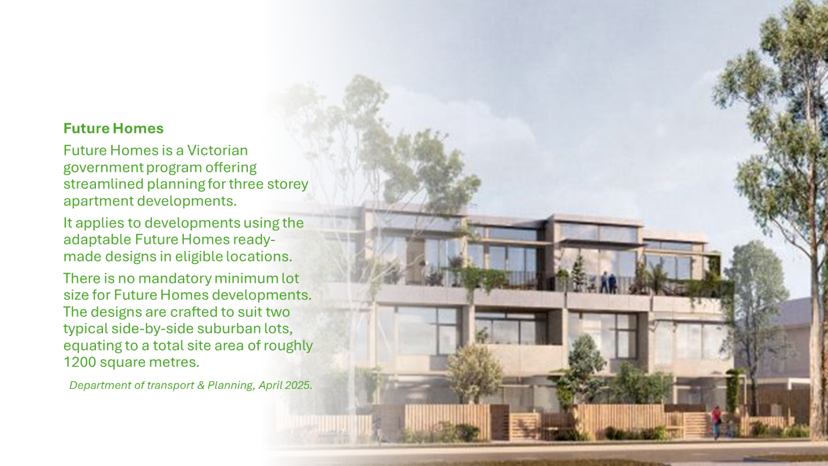

Inclusionary Zoning
Inclusionary zoning is a land use planning intervention that mandates or creates incentives for residential development that includes a proportion of social or affordable homes. Inclusionary zoning supports the development of affordable and social housing in good locations, ensuring housing that is affordable for essential and key workers on lower incomes. Inclusionary zoning can be a mechanism to seek affordable housing contributions from developers in the form of either land, dwellings, or cash contributions.
Inclusionary zoning can be mandatory or voluntary. In the mandatory model the number of potential affordable homes developers are obliged to build is determined by negotiated agreements between the developer and planning authority, or fixed requirements specified as a proportion of housing or development value.
In the voluntary incentive model new affordable housing is encouraged by reducing costs for developers. These include:
- modifying planning standards based on performance criteria such as increasing site yield to encourage low cost housing like boarding houses, student accommodation, and retirement villages.
- bonus systems which relax specified development controls, i.e. height, density, setback etc.
- planning process incentives where projects that include affordable housing attract special treatment such as fast track approvals.
Victoria does not have a mandatory statewide mechanism for inclusionary zoning. Notwithstanding, the state government gave in principle support to investigate inclusionary zoning following the parliamentary inquiry into homelessness. The Department of Transport and Planning has an inclusionary housing pilot on six surplus government land parcels, delivering a mix of social, affordable and market housing.
However, for inclusionary zoning to be introduced in Victoria, a significant shift in planning policy together with legislative reform would be needed by State Government. Nonetheless, some councils have decided to implement inclusionary zoning at the local planning scheme level.
- Yarra City Council requires at least 10% affordable housing in all rezonings for residential use and significant developments of 50 or more dwellings.
- Monash City Council requires an affordable housing contribution in rezonings for residential development or in developments of 20 or more dwellings.
- Whitehorse City Council encourages developers to voluntarily contribute to affordable housing and advocates for inclusionary zoning through collaborations like the Eastern Affordable Housing Alliance.
- The Municipal Association of Victoria (MAV) Social and Affordable Housing Victorian Local Government Position Statement supports implementation of planning mechanisms, including inclusionary zoning, that enable councils to seek mandatory affordable housing contributions from developers in a form directed by council of either land, dwellings, or cash contributions.

Wyndham Approach – Inclusionary Zoning
Wyndham City supports a well-designed statewide mandatory inclusionary zoning scheme which has enormous potential to deliver much needed social and affordable homes.

Affordable Housing Contribution
In the absence of an inclusionary zoning control, Council can encourage affordable housing through incentives, promoting planning initiatives that can raise funds to support the provision of social and affordable housing. Council can require developers to include an Affordable Housing Contribution as part of a planning scheme amendment or permit approval process, known as Section 173 Agreements. Wyndham City has used such agreements in relation to infrastructure developments but not yet specifically for afffordable housing.
Section 173 agreements are voluntary and enable council and landowner to reach a mutual agreement and obligation. For example, Bayside City Council granted a planning permit for a multi dwelling development in Hampton East which required the landowner to enter into a Section 173 Agreement with Council for affordable housing.
The condition of the planning permit states:
Before the commencement of the development, an agreement under Section 173 of the Planning and Environment Act 1987 must be entered into between the owner and the Responsible Authority in a form satisfactory to the Responsible Authority including:
a) A minimum of 10% of the proposed dwellings must be allocated for a rent-to-buy Key Worker Affordable Housing scheme and the dwelling mix must include a range of dwelling sizes.
b) A contribution of 0.1% from the sale of each dwelling must be provided for a Social Housing funding scheme such as Homes for Homes. This is to be applied at each sale, not limited to a once off.
c) A requirement that the owner pay the costs of the Responsible Authority in relation to the agreement.

Wyndham Approach – Affordable Housing Contribution
In negotiation, Wyndham City should seek a percentage of proposed dwellings to be allocated to an affordable housing scheme or leased to a registered housing agency, via planning incentives such as allowing for variations to discretionary height controls to provide for affordable housing.
Housing Trust
Council could establish a Wyndham Housing Trust, as a mechanism to collect donations expressly for social and affordable housing in Wyndham. Many Councils have established a local housing trust to receive deposits of land, philanthropic and cash donations, inheritance bequests and other donations, for the purposes of growing affordable housing locally for the benefit of their communities.
- Hobson’s Bay Affordable Housing Trust - since 2020 the trust has collected, held and managed assets in the form of dwellings, land, or cash. The trust also promotes contributions from developers for affordable housing to benefit eligible residents on low incomes through the planning scheme (permit conditions and/or a section 173 agreement).
- Merri-bek Affordable Housing Ltd - approved by Council in 2017, is a not-for-profit company established to help address the need for affordable and secure housing for disadvantaged residents of Merri-bek, partnering with Haven Homes Safe (CHP).
- Port Phillip Housing Trust - the City of Port Phillip established the trust in 2004 to take ownership of its community housing assets, appointing HousingFirst as its trustee. HousingFirst secured $20 million in State Government housing funding for the Trust in its first few years. HousingFirst is an experienced facilities manager with a portfolio comprising multi-unit high density residential projects and assets circa $400 million.
- Mount Alexander Affordable Housing Trust - Mount Alexander Shire Council established the trust in June 2024 as an independent charitable organisation to hold land and money to be used for local affordable housing solutions. Council allocated $500K from the 2024-2025 Budget to establish the trust.
The process would include Council establishing a Special Purpose Vehicle (SPV), a subsidiary company, to undertake specific business activity, in this case Affordable Housing with a trustee appointed to manage the assets of the Trust (to minimise legal and financial risks for Council).
The trust would be established as a distinct legal entity to ensure administrative distance; a corporation or statutory body with its own governance structure, independent management, and separate financial accounts. The trustee would be required to report to Council, on a regular basis, the activities of the Trust and its progress against defined objectives. A key objective of the Trust could be to create and provide social and affordable housing that meets the needs of the Wyndham community.
Wyndham Approach – Housing Trust
Council will explore the process of establishing the Wyndham Affordable Housing Trust under the new strategy.
Council owned land and infrastructure
While Wyndham City is a substantial land owner, there is little unallocated or unused vacant land. The majority of vacant land consists of reserves or is earmarked for future use having been acquired for specific purposes by Council Resolution. The use of earmarked land for any other use would require a Council Resolution.
Establishing an Affordable Housing Trust would create the opportunity to accumulate funds under the trust to purchase land specifically for affordable housing in future. A trust provides a form of sustainability when focussed on providing long-term social and affordable housing. Through time, once Council has sufficient land holdings, ground lease becomes a viable option.
Ground Lease
The Local Government Act 2020, Section 115, provides that a council can enter into a lease for up to a maximum term of 50 years. Ground leases are commonly used by commercial landlords, who typically lease land for 50 to 99 years to tenants who construct buildings on the property.
The model is consistent with the state government’s Ground Lease Model for social housing. Under this model, Homes Victoria leases land to a consortium to build, operate and maintain housing on the site for 40 years. The land returns to public ownership at the end of the lease term. Thus the land would return to Council ownership on expiry of the ground lease.
The contribution of Council land at nil or minimal cost to a community housing provider is a key element to facilitate social and affordable housing projects, together with the community housing provider’s ability to access government funding and debt financing.
Council Infrastructure
Council owns, maintains and operates substantial community infrastructure in Wyndham such as car parks, libraries, community centres and recreation centres. Council could consider incorporating social and affordable housing into new or refurbished Council owned community buildings.
Air Rights
Traditionally, landowner property rights extend to the surface of the land on title, to the soil beneath it and the air above it, the ‘air rights’. Air rights are essentially the rights of an owner to control and develop a specific amount of unused air space above real property, such as using their air rights to add more floors to an existing building.
Air rights have value particularly in areas of medium and high density housing, and mixed use zones. Air rights significantly expand the stock of developable land. For example, in 2018, the Victorian Civil and Administrative Tribunal (VCAT) granted a permit for an eight-storey development on land at 121-123 Commercial Road and the airspace over the railway on the Sandringham line owned by VicTrack.
Air rights over car parks have great potential. While the car park is closed during the construction phase, it is reopened for use once the building is completed. Using air rights provides access to state and federal funding streams.
- In 2012, the City of Port Phillip transformed the air space above a council carpark at Kyme Place, Port Melbourne into a vibrant community for 27 long-term residents to remain in their local area.
- In 2022, the City of Melbourne (as part of the Queen Victoria Market Precinct Renewal), built the QVM Munro Precinct comprising 49 affordable housing dwellings, a 500 underground car park, 490 build to rent residences, a 110-room hotel, 2,000m² of ground floor retail, hospitality, and the City’s largest community hub and library (narrm ngarggu).
Wyndham Approach – Council Owned Land and Infrastructure
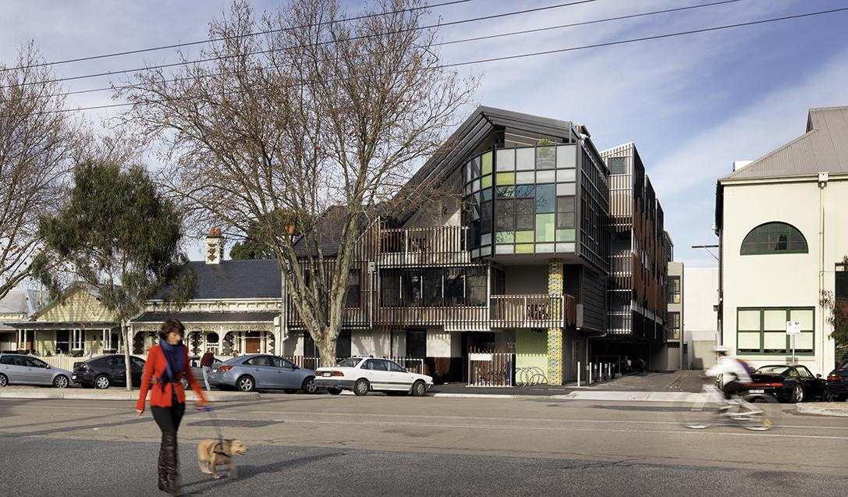
Based on first establishing a Wyndham Affordable Housing Trust, Council will explore opportunities to build affordable housing on Council owned land, community infrastructure and air rights together with a Community Housing Organisation.
Kyme Place, Port Melbourne (City of Port Phillip)
Partnerships
The previous Affordable Housing Strategy 2022-2025 laid the groundwork for social and affordable housing in Wyndham. Through that strategy we succeeded in updating the Wyndham Planning Scheme to incorporate objectives to facilitate Affordable Housing, making the Affordable Housing Strategy a reference document. In this we worked closely with colleagues across Council.
We also assisted community housing providers Unison Housing, Melbourne City Mission, Haven Home safe and Women’s Housing Limited to develop social and affordable housing across Wyndham. We continue to work closely with state government partners Homes Victoria for more social housing in Wyndham and the Victorian Planning Authority (VPA) around more housing choice through a review of precinct structure plans (PSPs).
Council can also partner with other local authorities to strengthen advocacy platforms. Many municipalities are encountering similar housing issues and lack of state government investment in local social housing. For example, the Eastern Affordable Housing Alliance, formed in 2009, unites six local councils – Knox, Manningham, Maroondah, Monash, Whitehorse and Yarra Ranges. Together they advocate for increased investment in social and affordable housing acknowledging that it requires a partnership with Local Government to enable the challenges of supply and demand to be met in the region.
The next Strategy could also consider innovative projects that support the more vulnerable members of our community. This could be through partnerships such as that currently operating at the Unison development in Cottrell Street, Werribee where IPC Health is on site to assist and support tenants. Projects like this better support successful tenancies by ensuring that residents have the necessary local supports in place. The Council Plan incorporating the Municipal Public Health and Wellbeing Plan 2025-2029 supports projects of this kind.
Wyndham Approach - Partnerships

Council can:
strengthen relationships between developers, community housing providers
demonstrate readiness to assist and facilitate social and affordable housing
actively encourage affordable housing projects.
explore partnership opportunities with neighbouring Councils

Homeless and at risk residents
For vulnerable households renting in the private market, high housing costs can result in insecure and overcrowded housing, food insecurity, or homelessness. Households experiencing family violence, those living with a disability or complex needs, and households on very low incomes are at risk of experiencing homelessness without additional support.
The Wyndham Health Homelessness and Housing (H3) Alliance is supported by state government and Council funding, partnering with health, housing and homelessness service providers who work collectively across the municipality to address issues that lead to housing vulnerability for residents. In recognition that homelessness is often the result of multiple and intersecting causes the Alliance uses a Collective Impact Model to maximise resourcing in collaboration. Through the work of the Alliance Council works to support Wyndham residents in housing crisis.

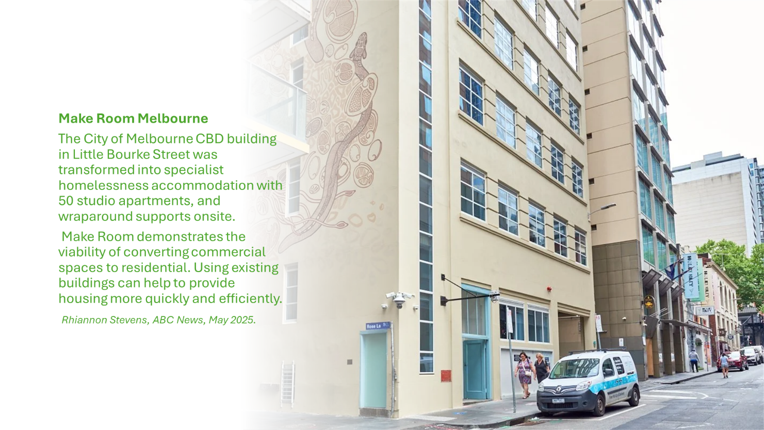
H3 Alliance partner Unison Housing is the central access point for households at risk of or experiencing homelessness in Wyndham. Partner Melbourne City Mission (MCM) specialises in assisting young people who experience homelessness appreciating their particular needs, especially those exiting out-of-home care. In Victoria, children must leave out-of-home care at 18 years. However, the state government offers support programs like Home Stretch and Better Futures that extend support up to the age of 21. In 2021, in partnership with MCM, Unison opened a youth foyer, providing supported accommodation for young people in Werribee, funded by the Victorian Government via the H3 Alliance.
The integrated Foyer approach breaks the cycle of disadvantage for young people who cannot live safely at home. Foyer accommodation provides a safe and stable home for 16 to 24-year-olds at risk of or experiencing homelessness by integrating housing with education, employment and life skills supports. Projects like this better support successful tenancies by ensuring that residents have the necessary local supports in place.
Wyndham Approach – Homeless and at risk residents
Continue to support and work with H3 Alliance partners to improve client outcomes through advocacy. Trial proactive and informed approaches that support people currently at risk of, or experiencing homelessness across Wyndham.

Affordable Housing Targets
Affordable housing targets represent a public commitment by Council to affordable housing in the municipality intended to drive actions that encourage increased affordable housing delivery. Targets can be set as a number of affordable homes to be provided each year, or as a percentage of housing stock. Homes Victoria Local Area Plans set targets at state government level for social and affordable housing for municipalities across Victoria.
Many of these additional homes will be in direct response to the Plan for Victoria Housing Targets. Plan for Victoria includes housing targets for every Victorian LGA, with the aim of increasing the availability and affordability of homes by building an additional 2.24 million dwellings statewide by 2051.
Plan for Victoria Housing Targets for Wyndham by 2051
Targets are based on:  - proximity to jobs and services  - access to existing and planned public transport  - environmental hazards including flood and bushfire risk  - development trends and places already identified for more homes  - development potential in established regional cities | Total additional homes to 2051 |  | + 99,000
 | Non-greenfield target |  | + 25,000
 | Greenfield target |  | + 74,000
 | Annual targets to 2051 |  | +3,807

However, meeting housing targets can be problematic. To work, targets need to be realistically achievable in market conditions and the current regulatory framework. Generally, targets can be achieved when there is alignment with streamlined planning processes, agreement in building higher-density housing in accessible areas and unlocking surplus government land. Thus, strong advocacy would be required for state government to unlock crown land in Wyndham such as the East Werribee Precinct.
Wyndham Approach – Affordable Housing Targets
Wyndham will adopt a whole-of-council approach to the delivery of affordable housing in the municipality to encourage affordable housing delivery.

Definitions
Affordable Housing
Affordable housing is housing that is appropriate for the needs of a range of very low to moderate income households, and priced (whether mortgage repayments or rent) so these households are able to meet their other essential basic living costs.
Community Housing
Community housing is delivered and managed by not-for-profit organisations that are experts in creating supportive and connected rental communities for people with low incomes or with special needs (such as living with a disability), including those eligible for public housing.
Housing Agencies are registered under the Housing Act 1983. Registered housing agencies:
- May own, manage and develop affordable rental housing
- May provide a range of housing support and assistance to clients
- Are viable businesses partnering with both government and the community
- Have met registration criteria, and continue to meet ongoing compliance requirements as well as demonstrate continuous improvement.

Housing Stress
Housing stress is the result when housing costs rise too far above household incomes and households have to pay too large a proportion of their income in housing costs, thereby reducing income available for other essentials such as food and health).
The 30:40 indicator identifies households in housing affordability stress when the household has an income level in the bottom 40 per cent of Australia's income distribution and is paying more than 30 per cent of income in housing costs. The assumption is that those on higher incomes who pay more than 30 percent of their income for housing are more able to afford do so and that this has little impact on the household's ability to buy life's necessities (such as food, health care, education etc.).
Homelessness
The Australian Bureau of Statistics uses six operational groups for presenting estimates of people experiencing homelessness on Census night. These groups are:
- people living in improvised dwellings, tents or sleeping out
- people living in supported accommodation for the homeless
- people staying temporarily with other households
- people living in boarding houses
- people in other temporary lodgings
- people living in ‘severely’ crowded dwellings.
The ABS also compiles estimates from Census data for the following three groups of people who may be marginally housed but are not classified as homeless:
- people living in other crowded dwellings
- people in other improvised dwellings
- people marginally housed in caravan parks.
Housing Stress
Housing stress is when households pay too large a proportion of their income in housing costs (and thereby reduce spending on other essentials such as food and health). It is the result of housing costs rising too far above household incomes.
The 30:40 indicator is commonly used to identify households in housing affordability stress. This means that the household has an income level in the bottom 40% of Australia's income distribution and is paying more than 30% of its income in housing costs.
Inclusionary Zoning
Inclusionary zoning is a land use planning intervention by government that either mandates or creates incentives so that a proportion of a residential development includes a number of social or affordable housing dwellings.
The benefits of inclusionary zoning include supporting the development of affordable and social housing in good locations, and ensures presence of essential and key workers on lower incomes in places where property prices and rents might be otherwise prohibitive.

Key Worker – Essential Worker
There is no consistent or universal definition of what constitutes a key worker, nor is the term universal, with ‘essential worker’ often having the same meaning.
In Australia, and internationally, key public service workers, whose wages are typically set at a national or state level, including teachers, nurses, police and fire and emergency personnel, are classed as key workers.
Public Housing
The aim of public housing is to provide long term, secure, and affordable housing to people and families on low incomes. Public housing is owned and managed by the Director of Housing (Victoria). The State Government provides public housing to eligible disadvantaged Victorians including those unemployed, on low incomes, living with a disability, with a mental illness or at risk of homelessness.
Section 173 Agreement
The Planning and Environment Act 1987, section 173 allows a responsible authority (Council, or the Minister) to negotiate an agreement with an owner of land to set out conditions or restrictions on the use or development of the land, or to achieve other planning objectives in relation to the land.
The purpose of an agreement is to make it easier to achieve specific planning objectives for an area or particular parcel of land than is possible with other statutory mechanisms. For example, to better facilitate affordable housing outcomes.
Social Housing
Social housing is short and long-term rental housing that is owned and run by the government or not-for-profit agencies.
In Victoria, social housing rents are capped at 25 – 30% of household income. This ensures that rents remain manageable, even if a renters' income changes.
Social housing is made up of two types of housing, public housing and community housing. It is for people on low incomes who need housing, especially those who have recently experienced homelessness, family violence or have other special needs.

References
Anglicare Victoria. (2025). Rental Affordability 2025 Snapshot. Retrieved from Anglicare Victoria: https://www.anglicarevic.org.au/research/victorian-rental-affordability-snapshot-2025/
Australian Bureau of Statistics. (2011, August). 2050.0.55.002 - Position Paper - ABS Review of Counting the Homeless Methodology. Retrieved from ABS: https://www.abs.gov.au/ausstats/abs@.nsf/0/D27107E6A3B6EAF3CA2578E20019328F?opendocument
Australian Bureau of Statistics. (2022, April 28). Housing Survey of Income and Housing, User Guide, Australia. Retrieved from ABS.
Australian Bureau of Statistics. (2023, March 22). Estimating Homelessness: Census. Retrieved from ABS: https://www.abs.gov.au/statistics/people/housing/estimating-homelessness-census/2021
Australian Housing and Urban Research Institute. (2019, May 23). Understanding the 30:40 indicator of housing affordability stress. Retrieved from AHURI: https://www.ahuri.edu.au/analysis/brief/understanding-3040-indicator-housing-affordability-stress
Australian Housing and Urban Research Institute. (2021, May). Policy Evidence Summary. Housing for Australia's Key Workers. Retrieved from AHURI: https://www.ahuri.edu.au/sites/default/files/migration/documents/Housing-for-Australias-key-workers.pdf
Australian Housing and Urban Research Institute. (2022, July 6). What is the right level of social housing for Australia? Retrieved from AHURI: https://www.ahuri.edu.au/analysis/brief/what-right-level-social-housing-australia
Australian Housing and Urban Research Institute. (2023, August 29). What is Inclusionary Zoning, and how does it help deliver affordable housing. Retrieved from AHURI: https://www.ahuri.edu.au/analysis/brief/what-inclusionary-zoning-and-how-does-it-help-deliver-affordable-housing
Azize, M. (2025). Out of Reach: Australia's Rental Crisis and the Decline of Social Housing. Melbourne: Everybody's Home.
Bayside City Council. (2021). Bayside Affordable Housing Strategy Background Report . Retrieved from Bayside City Council: https://www.bayside.vic.gov.au/sites/default/files/2021-08/affordable_housing_background_report_2021.pdf
Bentley, R., & Baker, E. (2020, October 26). Mould and damp health costs are about 3 times those of sugary drinks. We need a healthy housing agenda. Retrieved from The Conversation: https://theconversation.com/mould-and-damp-health-costs-are-about-3-times-those-of-sugary-drinks-we-need-a-healthy-housing-agenda-147743
City of Melbourne. (2025). Make Room. Retrieved from City of Melbourne: https://www.melbourne.vic.gov.au/make-room
Department of Transport and Planning (B). (2025, April 16). Inclusionary housing pilot. Retrieved from DTP: https://www.planning.vic.gov.au/guides-and-resources/strategies-and-initiatives/housing/inclusionary-housing-pilot
Department of Transport and Planning. (2024, July 2). Chapter 8: Agreements. Understanding 173 agreements. Retrieved from Department of Transport and Planning: https://www.planning.vic.gov.au/guides-and-resources/guides/guide-to-victorias-planning-system/chapter-8-agreements
Department of Transport and Planning. (2025, September 17). DFP expedited planning pathways guidance. Retrieved from DTP: https://www.planning.vic.gov.au/planning-approvals/planning-enquiries-and-requests/development-facilitation-program/expedited-planning-pathways
Department of Transport and Planning. (2025, April). Future Homes. Retrieved from DTP: https://www.planning.vic.gov.au/guides-and-resources/strategies-and-initiatives/future-homes#heading-4
Eastern Affordable Housing Alliance. (2025). Ensuring our communities have the shelter they need to thrive. Retrieved from EAHA: https://eaha.org.au/
HillPDA Consulting. (May, 2024). Bayside Affordable Housing Options Paper. Melbourne: City of Bayside.
Housing Victoria. (2024, June 19). Social Housing. Retrieved from Housing Victoria: https://www.housing.vic.gov.au/social-housing
Legislative Council Legal and Social Issues Committee. (2024, February 20). Inquiry into homelessness in Victoria. Retrieved from Parliament of Victoria: https://www.parliament.vic.gov.au/get-involved/inquiries/inquiry-into-homelessness-in-victoria/reports
Lincoln Institute of Land Policy. (2015). Inclusionary Housing. Creating and Maintaining Equitable Communities. Policy Focus Report. Cambridge, MA: Lincoln Institute of Land Policy.
Municipal Association of Victoria . (2025). Social and affordable housing, Current Priorities. Retrieved from MAV: https://www.mav.asn.au/what-we-do/policy-advocacy/social-and-affordable-housing#:~:text=Current%20priorities,from%20all%20Victorian%20member%20councils.
National Housing Supply and Affordability Council. (2025). State of the Housing System. Retrieved from National Housing Supply and Affordability Council: https://nhsac.gov.au/reports-and-submissions/state-housing-system-2025
NSW Productivity and Equality Commission. (2024). Review of housing supply challenge and policy options for New South Wales. Sydney: August.
Pawson, H. (2025, June 17). Building our way outt of social housing unaffordability may no longer be possible. Retrieved from The Guardian: https://www.theguardian.com/commentisfree/2025/jun/17/building-our-way-out-of-social-housing-unaffordability-may-no-longer-be-possible
Picketty, T., & Sandel, M. (2025). Equality. What It Means and Why It Matters. Cambridge, UK: Polity Press.
Qu, L., Baxter, J., & Gorniak, M. (2023, July). Households shrink as more people living alone. Retrieved from Australian Institute of Family Studies: https://aifs.gov.au/media/households-shrink-more-people-living-alone
SGS Economics and Planning. (2025). Growing Social Housing: Data, insights and targets. Melbourne: SGS Economic and Planning.
Snyder, J. (2018, April 10). A Slice of Heaven. The Development Potential of Air Rights in Victoria. Retrieved from Best Hooper Lawyers: https://www.besthooper.com.au/Insights-library/a-slice-of-heaven-the-development-potential-of-air-rights-in-victoria/
The Salvation Army. (2025). The Red Shield Report. Retrieved from The Salvation Army: https://www.salvationarmy.org.au/about-us/news-and-stories/publications-and-resources/the-red-shield-report-2025/
Unison Housing. (2025). A new home for youths experiencing homelessness. Retrieved from Unison: https://unison.org.au/about-us/our-properties/market-road-werribee
Victorian Auditor-General's Office. (2024, June 19). Planning Social Housing. Retrieved from VAGO : https://www.audit.vic.gov.au/report/planning_social_housing?section=#:~:text=There%20is%20demand%20for%20social,by%20their%20level%20of%20demand.
Witte, E. (2017). The case for investing in last resort housing. MSSI Issues Paper No. 10. Retrieved from Melbourne Sustainability Society Institute, University of Melbourne: https://www.unimelb.edu.au/newsroom/news/2017/march/providing-housing-for-homeless-is-cheaper-and-better-for-society
World Health Organisation. (2018, November 23). WHO Housing and Health Guidelines. Retrieved from WHO: https://www.who.int/publications/i/item/9789241550376
Wyndham Housing Monitor. (2025, October 3). Retrieved from Wyndham Housing Monitor: https://housing.id.com.au/wyndham/
Ziaesaeidi, P. (2025, May 23). More than just supply: building homes for social connection. Retrieved from The Policymaker: https://thepolicymaker.appi.org.au/more-than-just-supply-building-homes-for-social-connection/?utm_medium=email&_hsenc=p2ANqtz-_LKJWM1gT_Rx0Nn5OJbA7rKqnA3zN_9y7nbrdDdkX6KbGcftGJAt9XyKsLf7Srs48nnh_TY9TiX35GCVtZKLsH9GVP7TUutZRdnmKj8lw0m1f3rWo5Fqo2Nnj_cBt050

Appendix

Income Ranges for Affordable Housing
The Victorian Government specifies income ranges for affordable housing that is not social housing for the purposes of the Planning and Environment Act 1987. From 1 July 2025 these limits are as follows.
Annual Income Ranges | Very low | Low income | Moderate
Single adult | Up to $30,870 | $30,871 to $49,380 | $49,381 to $74,080
Couple, no dependant | Up to $46,290 | $46,291 to $74,080 | $74,081 to $111,110
Family (with one or two parents) and dependent children | Up to $64,810 | $64,811 to $103,710 | $103,711 to $155,550

Achievements of the Affordable Housing Strategy 2022-2025
KEY STRATEGIC ACTION | OUTCOME
Facilitate a forum for Housing Agencies to present to developers on housing needs, partnership models and opportunities | 2023  - Successful Wyndham housing Forum held at Encore Events on 8 February 2023 with 95+ attendees including an expert panel.  - The Wyndham Affordable Housing Strategy launched at the forum.
Advocate to improve older women’s housing outcomes in Wyndham | 2023-2024  Social Policy supported community housing providers:  - Women’s Housing Ltd - Allura Estate, Truganina for older women.  - Haven Home Safe - Stewart Drive, Werribee (mixed tenure).  Homelessness Week event 2023  - H3 Alliance and Neighbourhood Houses screening ‘Under Cover’ documentary to raise awareness of older women’s specific housing needs.
Other advocacy | 2024 -2025  - Submission to the Commonwealth Government Issues Paper on a National Housing and Homelessness Plan.  - Advocated to state government in support of Melbourne City Mission’s drive for youth housing needs.  - Strengthened Council’s advocacy on social and affordable housing.
Promote a greater understanding of Affordable Housing need in Wyndham | 2022  - Wyndham Affordable Housing Forum launching the Strategy.  - Collaboration with Health Homelessness and Housing (H3) Alliance partners.
Update the Planning Scheme to incorporate objectives to facilitate Affordable Housing, making the Affordable Housing Strategy a reference document | - Included in the Wyndham Planning Scheme review to ensure key objectives and strategies incorporated.  - Planning Scheme Review 2022-2024 submitted to the department for approval.  - Affordable Housing Strategy included in the amendment as a reference document.
Promote housing diversity including apartments and town houses consistent with Council planning policy | 2022-2024  - Action supported with adoption of the Housing and Neighbourhood Character Strategy 2023 and The Wyndham Plan in 2024.  - Together with the Affordable Housing Strategy, Wyndham City policy is consistent in promoting higher density housing development in Activity Centres and around train stations.
Support H3 Alliance advocacy for long-term investment in Affordable Housing | 2022 - 2024  - Clearer organisational alignment of H3 Alliance Local Area Coordination within Council including the Operational Partnership Group (OPG) and the Strategic Partnership Group (SPG) with coordination funded by Homes Victoria and in-kind contributions from Council.  - The SPG meetings included strategic planning discussions to identify alignment with the Affordable Housing Strategy, ongoing advocacy positions.
Identify Council practices where interaction with at-risk or homeless households may be increased | 2023 - 2024  - H3 Alliance Rough Sleeper Outreach program initiated.  - Wyndham Community Connectors trained to assist with inquiries and referrals.  - Council for Homelessness Persons (CHP) online training package rolled out via ‘Connect Respect’ to Community Connectors, Wyndham Libraries, Community Centres, Local Laws, and local traders.  - Online training modules were embedded in Council’s new LMS Litmos. Six online Q&A sessions completed with H3 Alliance Service Providers and CHP peer support workers.  - Privacy Impact Assessment resource developed to assist officers in collecting information on homeless community at point of contact, including at Council sites, building staff capacity.  - Draft Wyndham Homelessness Protocol together with Victoria Police.



Refer to Appendix for achievements of the Affordable Housing Strategy 2022-2025.
Set out in Article 11(1) of the International Covenant on Economic, Social and Cultural Rights 1997 (ICESCR), which imposes positive obligations on State Parties to take appropriate steps to ensure the realisation of the right to adequate housing.
Wyndham Council Plan incorporating the Municipal Public Health and Wellbeing Plan 2025-2029.
Income ranges for affordable housing that is not social housing for the purposes of the Planning and Environment Act 1987 as of 1 July 2025. https://www.planning.vic.gov.au/__data/assets/pdf_file/0024/712590/Governor-in-Council-Order-2025.pdf Refer to Appendix 1 for further detail.
(Wyndham Housing Monitor, 2025)
(Azize, 2025)
City of Wyndham Population Forecast. Sourced 13 October 2025: https://forecast.id.com.au/wyndham
(World Health Organisation, 2018)
(Bentley & Baker, 2020)
(Lincoln Institute of Land Policy, 2015)
Ibid
(Witte, 2017)
(The Salvation Army, 2025)
ABS Census, 2021
City of Wyndham Population Forecast. Available at: https://forecast.id.com.au/wyndham/population-age-structure
Ibid
Recognised formal qualifications are Bachelor or higher degree; Advanced Diploma or Diploma; or Vocational qualifications.
(Qu, Baxter, & Gorniak, 2023)
(Australian Bureau of Statistics, 2011)
(Wyndham Housing Monitor, 2025)
(Ziaesaeidi, 2025)
Ibid
(Anglicare Victoria, 2025)
Ibid
(Australian Bureau of Statistics, 2022)
(Victorian Auditor-General's Office, 2024)
Ibid
(Ziaesaeidi, 2025)
(National Housing Supply and Affordability Council, 2025)
Ibid
(NSW Productivity and Equality Commission, 2024)
(National Housing Supply and Affordability Council, 2025)
(Australian Housing and Urban Research Institute, 2022)
ABS Census, 2021
(Azize, 2025)
(SGS Economics and Planning, 2025)
(Pawson, 2025)
(Pawson, 2025)
A list of NRAS approved participants in Victoria is available at: https://www.dss.gov.au/national-rental-affordability-scheme/resource/nras-approved-participants-victoria
Implementation schedule is available at: https://treasury.gov.au/policy-topics/housing/accord
Wyndham Population Forecast population to 2046. Retrieved 16 October 2025: https://forecast.id.com.au/wyndham This is similar to the population of Canberra, which is currently, 482,986 (ABS, 2025).
Planning Scheme Amendment C258wynd, 10 February 2022. Retrieved 13 October 2025: https://planning-schemes.app.planning.vic.gov.au/Wyndham/ordinance/02.03-6
(Australian Housing and Urban Research Institute, 2023)
(Department of Transport and Planning (B), 2025)
Ibid
(Legislative Council Legal and Social Issues Committee, 2024)
(Department of Transport and Planning (B), 2025)
(Municipal Association of Victoria , 2025)
Section 173, Planning and Environment Act 1987
(Bayside City Council, 2021)
(Snyder, 2018)
(NSW Productivity and Equality Commission, 2024)
Youth Foyers provide a safe and stable home for 16 to 24-year-olds at risk of or experiencing homelessness by integrating housing with education, employment and life skills supports. (Unison Housing, 2025)
For further information go to: https://engage.vic.gov.au/project/developing-a-new-plan-for-Victoria/page/housing-targets-2051
(HillPDA Consulting, May, 2024)
The East Werribee Precinct vision is for “a new centre for jobs and housing in Melbourne’s growing western corridor”. Retrieved 17 October 2025: https://www.vic.gov.au/east-werribee
The Planning and Environment Act 1987 includes the definition of affordable housing and an objective to facilitate the provision of affordable housing in Victoria. A Governor in Council Order forms part of the definition of affordable housing under the Act, specifying income ranges for very low, low and moderate-income households for affordable housing that is not social housing.
(Australian Housing and Urban Research Institute, 2019)
(Australian Bureau of Statistics, 2023)
(Australian Housing and Urban Research Institute, 2023)
(Australian Housing and Urban Research Institute, 2021)
(Department of Transport and Planning, 2024)
(Housing Victoria, 2024)

